
UNIVERSITY OF HERTFORDSHIRE

School of Physics, Engineering and Computer Science

MSc in Advanced Computer Science

Module Code: 7COM1039

Deep Learning - Based Brain Tumor Detection from MRI Images using Transfer Learning and Advanced Optimization Techniques.

Name: Divya Sridurga Munagala
Student ID: 22073913
Supervisor: Raghubir Singh

Date: 4/09/2025

Word count: 8602

MSc FPR Declaration
This report is submitted in partial fulfilment of the requirement for the degree of Master of Science in 7COM1039-0991-2024 - Advanced Computer Science Masters Project at the University of Hertfordshire (UH).

I hereby declare that the work presented in this project and report is entirely my own, except where explicitly stated otherwise. All sources of information and ideas, whether quoted directly or paraphrased, have been properly referenced in accordance with academic standards. I understand that any failure to properly acknowledge the work of others could constitute plagiarism and may result in academic penalties.

I did not use human participants in my MSc Project.

I hereby give permission for the report to be made available on the university website, provided the source is acknowledged.

Student signature: Divya Sridurga Munagala
Acknowledgement

I am sincerely thankful to my supervisor, Raghubir Singh, for the consistent guidance, encouragement, and valuable feedback that greatly contributed to the progress and completion of this thesis. I also extend my gratitude to the faculty members and staff of the University of Hertfordshire for providing the necessary resources and an enriching academic environment, as well as to my peers and friends whose support and discussions were of immense help during this journey.

Most importantly, I owe deep appreciation to my family for their constant love, patience, and motivation. Their belief in my abilities has been a source of strength and inspiration, enabling me to stay focused and determined throughout this work.
Abstract

Brain tumours are abnormal tissue growths in the brain that impair neurological functions and may lead to severe complications or death if undetected. Early and accurate diagnosis is therefore vital for improving treatment planning and survival outcomes. Glioma, meningioma, and pituitary tumours are the most common types, but their detection through manual interpretation of Magnetic Resonance Imaging (MRI) is labour-intensive, subjective, and prone to inter-observer variability (Ling, 2024). While MRI remains the diagnostic gold standard, the exponential rise in imaging data necessitates automated and scalable approaches for classification.

This project developed an optimised deep learning framework for multi-class brain tumour classification using the Kaggle Brain MRI dataset (7,023 images across four classes). The dataset was preprocessed through resizing, targeted augmentation, and oversampling to address class imbalance (Kalvakolanu, 2021; Kandula, 2024). A baseline Convolutional Neural Network (CNN) achieved 92% accuracy. Transfer learning models, including EfficientNetB0, ResNet50, and Xception, were fine-tuned with systematic hyperparameter optimisation using Optuna to explore learning rate, dropout, and optimiser choice (Karim, 2021). Experimental results showed that EfficientNetB0 underperformed at 85%, whereas ResNet50 and Xception achieved 96% and 97% accuracy, respectively. A dynamic weighted ensemble of ResNet50 and Xception further stabilised predictions, maintaining 97% accuracy with balanced precision (0.97), recall (0.97), and F1-score (0.97).

The findings demonstrate that integrating augmentation, balancing, transfer learning, hyperparameter optimisation, and ensemble methods produces a robust and reproducible framework, with potential for multimodal MRI integration and explainable AI in clinical practice.

Keywords: Brain tumour classification, MRI, deep learning, transfer learning, data augmentation, data balancing, ensemble learning, Optuna.

Table of contents

1. Introduction 9
1.1 Background and Domain of the Disease 9
1.2 Problem Statement and Current Issues 12
1.3 Project Details 13
1.4 Aim and Objectives 13
1.5 Research Significance, Questions, and Novelty 14
1.6 Scope, Feasibility, and Risks 15
1.7 Thesis Organization 15
2. PROJECT MANAGEMENT 17
2.1 Timeline and Milestones 17
3. Literature review 18
4. Methodology 23
4.1. Data 24
4.2 Exploratory Data Analysis (EDA) 27
4.3 Data Preprocessing, Balancing, and Augmentation 27
4.4 Dataset Splitting 29
4.4 Choice of Models, Justification and Support of Choices 30
4.4.1 Convolutional Neural Network (CNN) 30
4.4.2 Transfer Learning 31
4.4.3 EfficientNetB0 34
4.4.4 ResNet50 34
4.4.5. XceptionNet 35
4.4.6 Ensemble 36
4.5 Evaluation Metrics 37
4.6 Ethical, Legal, Professional and Social Issues 38
5. Quality and Results 40
5.1 Metrics and Presentation 40
5.2 Model Training, Validation, and Confusion Matrix Overview 41
5.3 Critical Analysis 46
5.4 Evidence of Practical Work 46
5.5 Technical Challenges and Solutions 47
6. Evaluation and Conclusion 47
6.1 Final Evaluation 48
6.2 Addressing Research Questions 48
6.3 Comparison to Literature 49
6.4 Project Management 49
6.5 Future Work 50
6.6 Conclusion 50
7. References 51
Glossary of Abbreviations

Abbreviation | Expansion
AI | Artificial Intelligence
AUC | Area Under the Curve
CBTRUS | Central Brain Tumor Registry of the United States
CE-T1 | Contrast-Enhanced T1-weighted MRI
CNS | Central Nervous System
CNN | Convolutional Neural Network
CT | Computed Tomography
EDA | Exploratory Data Analysis
FLAIR | Fluid-Attenuated Inversion Recovery
GDPR | General Data Protection Regulation
GPU | Graphics Processing Unit
GLOBOCAN | Global Cancer Observatory
hrT2 | High-Resolution T2-weighted MRI
ISO | International Organization for Standardization
KNN | K-Nearest Neighbour
LR | Learning Rate
MDR | (EU) Medical Device Regulation
ML | Machine Learning
MRI | Magnetic Resonance Imaging
Optuna (TPE) | Tree-structured Parzen Estimator (Optuna sampler)
PET | Positron Emission Tomography
ReLU | Rectified Linear Unit
ROC | Receiver Operating Characteristic
SMOTE | Synthetic Minority Oversampling Technique
ViT | Vision Transformer
XAI | Explainable Artificial Intelligence
EfficientNetB0 | EfficientNet (baseline, compound scaling)
ResNet50 | Residual Network (50 layers)
Xception | Extreme Inception (depthwise separable convolutions)
Adam | Adaptive Moment Estimation (optimizer)
AdamW | Adam with decoupled weight decay (optimizer)
Keras | High-level neural networks API
TF | TensorFlow
ACC | Accuracy
PR | Precision
REC | Recall
F1 | F1-score (harmonic mean of PR & REC)

List of Figures:

Figure 1: Representative MRI images of glioma, meningioma, pituitary, and no-tumour classes…………………………………………………………………………………………….11
Figure 2: MRI scans illustrating a vestibular schwannoma across multiple modalities…………12
Figure 3: Gantt chart of project timeline and milestones…………………………………….…..18
Figure 5: Sample MRI images of the four categories………………………………………..…..26
Figure 6: Class-wise image count (Train, Test) before balancing…………………………….…27
Figure 7: Class distribution before and after balancing………………………………………….27
Figure 8: Image width and height distribution histograms………………………………………28
Figure 9: Original vs. augmented samples for each class…………………………………….…29
Figure 10: Class-wise bar chart showing dataset splits across training, validation, and testing subsets………………………………………………….………………………………………...30
Figure 11: CNN architecture……………………………………………………………………..32
Figure 12: EfficientNetB0 Architecture………………………………………………………....35
Figure 13: Architecture of Resnet50……………………………………………………………..36
Figure 14: Xception architecture highlighting depthwise separable convolutions……………..37
Figure 15: Weighted Ensemble Model diagram………………………………………………....38
Figure 16: Test Accuracy Comparision: Models vs Ensemble…………………………………..42
Figure 17: CNN Accuracy and loss curves for training and validation………………………….43
Figure 18: CNN Model confusion matrix………………………………………………………..43
Figure 19: EfficientB0 training and validation accuracy and loss plot……………………….…44
Figure 20: EfficientB0 Model confusion matrix…………………………………………………44
Figure 21: Resnet50 training and validation accuracy and loss plot…………………………….45
Figure 22: Resnet50 Model confusion matrix…………………………………………………...45
Figure 23: XceptionNet training and validation accuracy and loss plot………………………....46
Figure 24: XceptionNetModel confusion matrix………………………………………………...46
Figure 25: Ensemble ( ResNet50 and XceptionNet ) Model confusion matrix………………….47

List of Tables:

Table 1: Research Challenges, Implications, and Addressed Contributions…………………….21
Table 2: Comparative Summary of Key Studies in Brain Tumour Classification Using MRI….22
Table 3: Dataset distribution before and after balancing………………………………………..27
Table 4: Search space used for Optuna hyperparameter optimisation…………………………..33
Table 5: Best hyperparameters identified by Optuna……………………………………………33
Table 6: Summary of model performance metrics on the test set……………………………….42
Table 7: Optuna hyperparameter optimisation search space and best results……………………43

1. Introduction
This chapter introduces the research context by outlining the clinical importance of brain tumour diagnosis and the role of Magnetic Resonance Imaging (MRI) as the diagnostic gold standard. It highlights the current challenges in manual interpretation and existing computational methods, thereby identifying research gaps. The project’s aims, objectives, significance, scope, and novelty are then presented, followed by a summary of the thesis structure.

1.1 Background and Domain of the Disease
Brain tumours are abnormal proliferations of cells within the brain or central nervous system (CNS) that disrupt neurological functions and can result in severe disability or death. They may be malignant or non-malignant, with their clinical behaviour determined by histological type, grade, and location. Malignant tumours typically grow rapidly and infiltrate adjacent tissue, while non-malignant tumours often progress more slowly but can still cause significant morbidity due to mass effects. Accurate and early detection is therefore vital to improve treatment planning and patient survival outcomes.

Epidemiology of Brain Tumours

The global burden of brain and CNS tumours remains substantial. According to the 2024 CBTRUS Statistical Report, the overall incidence rate of primary malignant and non-malignant brain and CNS tumours in the United States between 2017 and 2021 was 25.34 per 100,000 population, representing 467,894 new cases. Of these, 126,807 cases (6.89 per 100,000) were malignant and 341,087 cases (18.46 per 100,000) were non-malignant (Price et al., 2024). Incidence was higher in females (28.77 per 100,000) than in males (21.78 per 100,000).

On a global scale, the GLOBOCAN 2024 report estimated that 321,731 new malignant brain and CNS tumours were diagnosed in 2022, with an age-adjusted incidence rate of 3.5 per 100,000 population (Bray et al., 2024). Incidence rates were highest in high-income countries (4.9 per 100,000) compared to 2.4 per 100,000 in low- and middle-income countries, reflecting differences in healthcare access and diagnostic capacity.

Tumour Subtypes

Among the most common brain tumour categories are gliomas, meningiomas, and pituitary adenomas, which differ substantially in behaviour and clinical impact:

- Gliomas originate from glial cells such as astrocytes, oligodendrocytes, and ependymal cells. They represent the majority of malignant brain tumours, with glioblastoma (grade IV glioma) being the most lethal. Glioblastoma has a median survival of only 9–15 months, even with aggressive multimodal therapy (Price et al., 2024). Among adults over 40 years of age in the United States, glioblastoma is the most common malignant histology, with an incidence of 21.88 per 100,000.
- Meningiomas develop in the meninges, the membranes surrounding the brain and spinal cord. They account for nearly one-third of all CNS tumours and are the most frequent non-malignant type (Neff et al., 2023). While often benign, their location can cause compression of brain structures, leading to neurological symptoms. Meningiomas are more prevalent among females, reflecting hormonal influences in their pathogenesis (CBTRUS, 2024).
- Pituitary adenomas arise in the pituitary gland, which regulates critical hormonal pathways. They are one of the most common tumours in adolescents and young adults (15–39 years), with an incidence of 4.47 per 100,000 in this group (CBTRUS, 2024). Although typically benign, they can lead to systemic endocrine disorders such as acromegaly, Cushing’s disease, or infertility, underscoring their clinical importance (Bray et al., 2024).
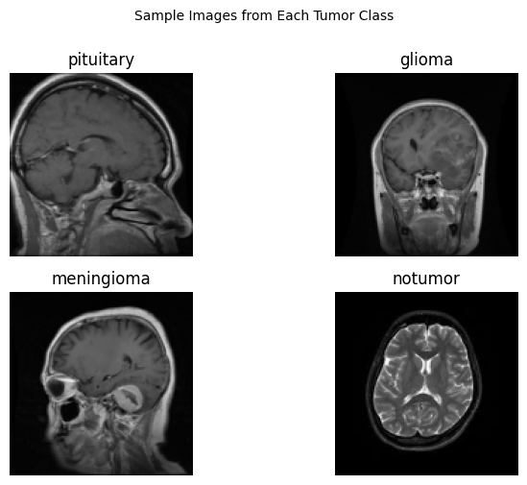
Figure 1: Representative MRI images of glioma, meningioma, pituitary, and no-tumour classes from the Kaggle Brain Tumour MRI dataset

Imaging and Diagnosis

Magnetic Resonance Imaging (MRI) is the gold standard for brain tumour detection due to its high spatial resolution, contrast sensitivity, and ability to capture multiple sequences without ionising radiation. T1-weighted images provide anatomical detail, T2-weighted scans highlight oedematous regions, and FLAIR sequences suppress cerebrospinal fluid, enhancing lesion visibility. Contrast-enhanced T1 (ceT1) images are particularly useful for delineating tumour margins and vascularisation (Saeedi et al., 2023).
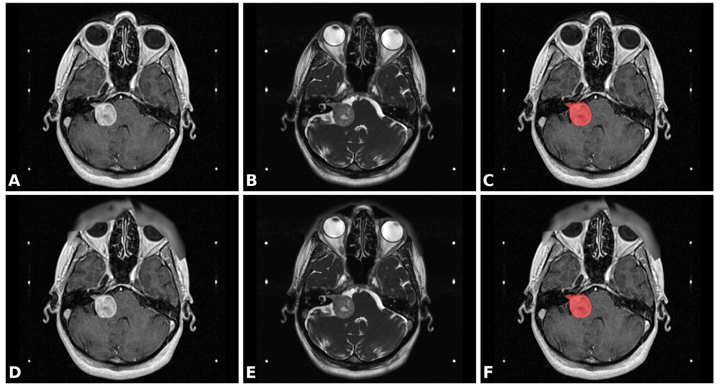

Figure 2: MRI scans illustrating a vestibular schwannoma across multiple modalities. (A) Contrast-enhanced T1-weighted (ceT1) MRI, (B) high-resolution T2-weighted (hrT2) MRI, (C) ceT1 MRI with annotated segmentation, and (D-F) corresponding images after obscuring facial features. Image adapted from Shapey et al. (2021).

Computational Approaches in Brain Tumour Diagnosis

Manual MRI interpretation is labour-intensive and subject to observer variability, with disagreement rates of up to 20% among radiologists (Senan et al., 2022). The rising volume of imaging data has accelerated the use of artificial intelligence (AI) in diagnosis. Convolutional Neural Networks (CNNs) are particularly effective for medical imaging tasks, as they can automatically extract hierarchical features from raw pixel data (Abdusalomov et al., 2023). Transfer learning, which leverages pre-trained models such as ResNet, EfficientNet, and Xception, has achieved classification accuracies exceeding 95% in brain MRI classification (Özkaraca et al., 2023). More recently, ensemble approaches have been shown to improve robustness by combining complementary model predictions (Novsheena et al., 2025).

Despite these advances, major challenges remain, including class imbalance in datasets, risk of overfitting, and limited reproducibility of results. These limitations emphasise the need for balanced, optimised, and reproducible frameworks for brain tumour classification that can complement radiologists and scale into clinical practice.

1.2 Problem Statement and Current Issues
Despite the critical role of Magnetic Resonance Imaging (MRI) in brain tumour diagnosis, several issues hinder timely and reliable clinical decision-making. Manual radiological interpretation, while considered the gold standard, is labour-intensive, time-consuming, and prone to inter-observer variability. Studies report that diagnostic agreement among radiologists can vary by 15-20%, particularly for complex or overlapping tumour morphologies (Senan et al., 2022). In high-volume clinical settings, these limitations contribute to delayed diagnoses and increased patient risk.

From a technical perspective, while Convolutional Neural Networks (CNNs) and transfer learning models have demonstrated strong performance in brain tumour classification, they face several persistent challenges:

- Class imbalance - Datasets such as brain MRI collections often contain far more images of some tumour types (e.g., glioma) than others (e.g., pituitary), leading models to overfit towards majority classes (Ozkaraca et al., 2023).
- Limited dataset size - Compared to natural image repositories like ImageNet, medical imaging datasets are relatively small, which constrains model generalisability and increases the risk of overfitting (Abdusalomov et al., 2023).
- Lack of systematic optimisation - Many existing studies do not implement rigorous hyperparameter optimisation strategies, resulting in models that are sensitive to training conditions and difficult to reproduce (Geetha et al., 2024).
- Variability in MRI modalities - Tumour appearance differs significantly across T1, T2, FLAIR, and contrast-enhanced scans, making standardisation a challenge and reducing cross-study comparability (Saeedi et al., 2023).
- Reproducibility and deployment gaps - Reported high accuracies in academic studies are rarely tested in real-world clinical workflows, limiting translation from research to practice (Novsheena et al., 2025).
These limitations demonstrate that although AI has advanced brain tumour diagnosis, current approaches are neither robust nor scalable enough for clinical adoption. There remains a pressing need for a comprehensive, optimised, and reproducible framework that integrates augmentation, balancing, transfer learning, hyperparameter optimisation, and ensemble methods to ensure fairness, robustness, and clinical relevance.

1.3 Project Details
This project developed an automated deep learning framework for brain tumour classification using the Kaggle Brain Tumour MRI dataset, which contains 7,023 images across four classes: glioma, meningioma, pituitary, and no tumour (Nickparvar, 2020). A baseline Convolutional Neural Network (CNN) was first implemented to establish a performance benchmark. To improve generalisation and fairness, data augmentation (rotation, flipping, zooming, shifting) and class balancing through oversampling were applied during preprocessing.

Building on this, three transfer learning models - EfficientNetB0, ResNet50, and Xception were fine-tuned. Performance was enhanced through Optuna-based hyperparameter optimisation, exploring learning rate, dropout, and optimiser choice. Finally, a dynamic weighted ensemble integrated the strongest models, improving robustness. The framework achieved up to 97% accuracy, demonstrating that combining augmentation, balancing, transfer learning, optimisation, and ensembles yields a reproducible and effective solution for brain tumour classification.

1.4 Aim and Objectives

Aim
The aim of this study was to develop an optimised and reproducible deep learning framework for multi-class brain tumour classification using MRI. The project specifically addressed challenges of class imbalance, overfitting, and reproducibility by integrating data augmentation, balancing, transfer learning, systematic hyperparameter optimisation, and ensemble learning to achieve higher accuracy and clinical reliability.

Objectives
The objectives of the study were to:

- Employ the Kaggle Brain Tumour MRI dataset, comprising four categories: glioma, meningioma, pituitary, and no tumour.
- Preprocess the dataset with image resizing, augmentation, and balancing techniques to improve fairness and model generalisation.
- Implement a baseline CNN to provide a comparative benchmark.
- Fine-tune transfer learning models (EfficientNetB0, ResNet50, and Xception) for classification tasks.
- Apply Optuna-based hyperparameter optimisation, including tuning learning rate, dropout, and optimiser choice (Adam vs AdamW), to enhance performance.
- Design a dynamic weighted ensemble to combine the strongest models and improve robustness.
- Rigorously evaluate models using metrics such as accuracy, precision, recall, F1-score, and confusion matrices.

1.5 Research Significance, Questions, and Novelty

Research Significance

Brain tumours present a major global health challenge, with over 321,000 new malignant cases worldwide in 2022 (Bray et al., 2024). While MRI remains the diagnostic gold standard, manual interpretation is labour-intensive, subjective, and unsustainable given rising imaging volumes (CBTRUS, 2024). Automated deep learning frameworks can support radiologists by improving speed, consistency, and diagnostic accuracy. Academically, this study contributes by developing an optimised and reproducible pipeline that integrates augmentation, balancing, transfer learning, hyperparameter optimisation, and ensemble learning - an approach designed to address key limitations of existing methods.
Research Questions

RQ1. How do data augmentation, class balancing, and regularisation techniques influence the generalisation ability, accuracy, and clinical relevance of CNN-based models for multi-class brain tumour classification using MRI scans?

RQ2. What is the comparative performance of a custom-built CNN versus advanced transfer learning architectures (EfficientNetB0, ResNet50, Xception) in improving diagnostic precision and applicability for brain tumour detection?

RQ3. To what extent can systematic hyperparameter optimisation (learning rate, dropout, optimiser choice) combined with ensemble learning further enhance robustness and reproducibility compared to individual models?

Novelty

- Combines augmentation, balancing, transfer learning, and Optuna-based optimisation in one unified framework.
- Introduces a dynamic weighted ensemble tailored to brain tumour classification.
- Focuses on reproducibility and clinical applicability, addressing gaps in current research.

1.6 Scope, Feasibility, and Risks

Scope of the Study

This project focused on classifying brain MRI images into four categories: glioma, meningioma, pituitary, and no tumour. The study employed a multi-stage pipeline including dataset preprocessing (augmentation, resizing, and balancing), a baseline CNN, transfer learning architectures (EfficientNetB0, ResNet50, and Xception), hyperparameter optimisation using Optuna, and a dynamic ensemble model. Performance evaluation was conducted using metrics such as accuracy, precision, recall, F1-score, and confusion matrices.

Out-of-scope aspects included three-dimensional volumetric MRI analysis, multi-modal imaging (CT or PET integration), histopathological correlation, and real-world clinical deployment. These areas were excluded to maintain focus on model development and reproducibility within the constraints of available resources.
Feasibility
The study was feasible due to the availability of a large open-source dataset (Kaggle Brain Tumour MRI), access to Google Colab GPU-enabled computational resources, and established deep learning frameworks such as TensorFlow and Keras. The modular design of the workflow also ensured adaptability for further research or clinical translation.
Risks and Limitations

Several risks were acknowledged. Dataset imbalance, despite augmentation and oversampling, may still affect model generalisability. Computational constraints limited experimentation with very deep architectures and extensive hyperparameter trials. Moreover, while the framework achieved high accuracy, its evaluation was restricted to a single dataset, raising concerns about robustness in cross-institutional or real-world clinical settings. Ethical and regulatory considerations for clinical adoption were beyond the scope of this study but remain essential for future deployment.

1.7 Thesis Organization

This thesis is structured into six chapters.

- Chapter 2 outlines project management, including timelines, milestones, and ethical considerations.
- Chapter 3 reviews the literature on brain tumour classification using MRI, deep learning, transfer learning, and optimisation, identifying research gaps.
- Chapter 4 presents the methodology, covering dataset preparation, preprocessing, augmentation, model design, hyperparameter optimisation, and evaluation metrics.
- Chapter 5 reports the experimental results, comparing baseline CNN, transfer learning models, and the ensemble framework.
- Chapter 6 discusses the findings, addresses the research questions, and highlights limitations and clinical implications.
- Finally, Chapter 7 concludes the study and suggests future research directions.

2. PROJECT MANAGEMENT

Effective project management was essential to ensure this research progressed systematically from project conception to final documentation. The project was divided into distinct but interrelated phases, each with clear deliverables and deadlines. A detailed Gantt chart (Figure 3) was created at the outset to guide the work, providing an overview of all major activities and their dependencies. This ensured that tasks were prioritised logically and that sufficient time was allocated for experimentation, evaluation, and report writing.

2.1 Timeline and Milestones
The project began with topic selection and a literature study, which laid the foundation for refining the research problem and identifying knowledge gaps. This was followed by data understanding, preprocessing, and exploratory data analysis (EDA) to familiarise with the dataset and address its challenges. Once the data was prepared, augmentation and balancing techniques were applied to mitigate class imbalance and improve the model’s generalisation capability.

The modelling phase was carried out in stages. A baseline CNN was first implemented to provide a performance benchmark. Building on this, three transfer learning models - EfficientNetB0, ResNet50, and Xception were fine-tuned for the classification task. To further improve accuracy and robustness, Optuna-based hyperparameter optimisation was employed, followed by the development of a dynamic ensemble model that combined the strongest architectures. The final stage of the project involved systematic evaluation and comparison of all models using multiple performance metrics. The last weeks were dedicated to documentation, ensuring that the methodology, results, and conclusions were clearly presented.

Overall, adherence to the planned schedule and milestones enabled the project to remain on track. While minor adjustments were made to accommodate computational demands during training, the structured management approach ensured that all objectives were achieved within the timeframe.

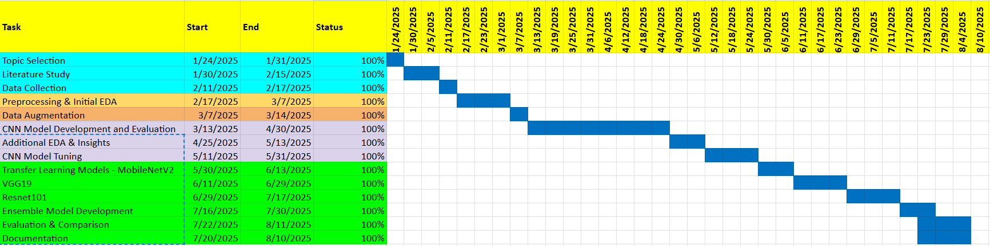

Figure 3: Gantt chart of project timeline and milestones

3. Literature review

3.1 Introduction to the Field

Brain tumour diagnosis and classification have become increasingly important in clinical practice due to their significant impact on patient survival and treatment planning. MRI remains the most widely used modality because of its superior soft tissue contrast and multi-sequence capabilities. However, manual interpretation of MRIs is labour-intensive and subject to inter-observer variability, making automated systems based on deep learning essential. Convolutional Neural Networks (CNNs) and transfer learning models have shown great promise, but challenges such as dataset imbalance, reproducibility, and generalisation persist (Imam and Alam, 2023; Guluwadi et al., 2024).

The following sections review recent contributions in this field, focusing on baseline CNNs, transfer learning, augmentation and balancing strategies, hyperparameter optimisation, ensemble learning, and explainability, followed by an analysis of key research gaps.

3.2 CNN-based Classification Approaches

CNNs are the foundation of medical image classification. Sharma et al. (2024) developed a CNN-based binary classifier using the BT Image Dataset, applying resizing, normalisation, and augmentation techniques. Their model achieved 97.29% accuracy, with high precision and recall. While this demonstrates CNNs’ potential, their study was limited to binary classification, failing to address the complexity of multiclass scenarios, such as glioma, meningioma, pituitary, and no-tumour cases.

Similarly, Gull et al. (2021) extended CNNs to 3D MRI segmentation and classification using the BRATS 2018 dataset. Their DenseNet-based classifier achieved 98.26% accuracy, outperforming DarkNet. The strength of this study lies in its integration of segmentation and classification; however, its heavy computational requirements limit scalability in real-world hospital settings.

Critical Analysis: CNNs offer strong feature extraction capabilities but often require large datasets to prevent overfitting. For multiclass problems, handcrafted CNNs struggle compared to transfer learning methods that leverage pretrained feature extractors.

3.3 Transfer Learning for Brain Tumour Classification

Transfer learning has become dominant due to its efficiency in leveraging pretrained weights. Bouguerra et al. (2022) employed VGG16 and VGG19 with preprocessing and augmentation, achieving 99.77% accuracy on binary classification tasks. While highly effective, the reliance on VGG architectures is now considered computationally heavy, limiting adaptability in clinical environments.

Talukder et al. (2023) advanced this by comparing Xception, ResNet50V2, InceptionResNetV2, and DenseNet201 on the Figshare dataset. ResNet50V2 achieved 99.68% accuracy, highlighting the strength of deeper residual networks for feature extraction. However, the study’s focus on a relatively small dataset (3,064 images) raises concerns about generalisability.

More recently, Mittal et al. (2024) applied DenseNet201 to the widely used 7,023-image Kaggle Brain Tumour MRI dataset, reporting 99% accuracy. While their work demonstrates scalability to multiclass tasks, it lacks systematic optimisation, making it difficult to reproduce or adapt across different datasets.

Díscio et al. (2025) provided the most relevant recent benchmark by testing six pretrained models (Xception, InceptionV3, ResNet50, MobileNetV2, VGG16, DenseNet121) on the Kaggle dataset. Xception achieved the highest weighted accuracy of 98.73% but struggled with recall in minority classes, suggesting ensemble approaches could improve robustness.

Critical Analysis: Transfer learning significantly outperforms custom CNNs, particularly for multiclass problems. However, studies often focus on single architectures or lack systematic optimisation, limiting reproducibility and robustness.

3.4 Data Augmentation and Class Balancing

Data augmentation is essential for improving generalisation. Sharma et al. (2024) used rotation and flipping to boost CNN performance. Similarly, Bouguerra et al. (2022) applied histogram equalisation and CLAHE for image enhancement. These studies confirm the role in boosting performance, but both stop short of evaluating how different augmentation strategies impact class-specific accuracy.

Class imbalance is another persistent issue. Imam and Alam (2023) demonstrated the effectiveness of SMOTE and ADASYN oversampling for CNN training, which improved minority class recall and achieved 96% accuracy. However, oversampling introduces synthetic bias, which may reduce performance in clinical deployment.

Critical Analysis: Augmentation and balancing are crucial yet underexplored areas that require systematic examination. Most studies apply generic augmentation without analysing its specific impact on minority classes such as pituitary tumours.

3.5 Hyperparameter Optimisation

Most deep learning studies rely on default settings or manual tuning. This reduces reproducibility and limits performance. Geetha et al. (2024) proposed a hybrid optimisation strategy combining metaheuristic algorithms with deep learning, significantly improving accuracy. However, these methods are computationally expensive.

Optuna, a modern framework for hyperparameter tuning, has been increasingly applied but rarely in brain tumour classification. Recent works outside brain imaging show Optuna can efficiently explore parameter spaces with less computational overhead, suggesting strong potential if applied to multiclass brain tumour tasks.

Critical Analysis: Hyperparameter optimisation is underrepresented in existing literature, despite being key to improving reproducibility. This represents one of the major gaps addressed in your project.
3.6 Ensemble Learning

While individual models achieve high accuracy, they often fail to generalise across datasets. Novsheena et al. (2025) introduced CNN-TumorNet, an ensemble approach with explainability, which achieves 97% accuracy and improves robustness compared to standalone models. Ensembles mitigate the weaknesses of single architectures but are rarely combined with systematic optimisation.

Critical Analysis: Ensemble methods offer robustness but remain underutilised, particularly in multiclass classification. Dynamic weighting strategies tailored to validation performance, as implemented in your project, are still uncommon.

3.7 Explainable AI and Clinical Relevance

A major barrier to clinical adoption is a lack of trust. Guluwadi et al. (2024) integrated ResNet50 with Grad-CAM to provide interpretable results, demonstrating how visual heatmaps can aid radiologists. While promising, their work was limited to binary classification. Extending explainability to multiclass settings is crucial for the real-world adoption of machine learning models.

Critical Analysis: Interpretability is increasingly recognised but underexplored in multiclass contexts. Your framework could be extended with explainability in future work.

3.8 Emerging Trends: Federated and Privacy-Preserving Learning
Albalawi et al. (2024) applied federated learning to brain MRI classification, achieving 98% accuracy while preserving patient privacy. This approach is valuable for cross-institutional learning, but it introduces communication overhead and requires infrastructure not available in many healthcare systems.
Critical Analysis: Although not within the scope of your project, federated learning highlights future directions for scalability and real-world integration.
3.9 Identification of Gaps

Research Gap | Implication | Your Project Contribution
Reliance on handcrafted CNNs or single pretrained models | Limits generalisation | Comparison of EfficientNetB0, ResNet50, Xception under same framework
Limited handling of class imbalance | Biased predictions towards majority classes | Systematic augmentation + oversampling to improve fairness
Lack of systematic hyperparameter optimisation | Difficult to reproduce or scale | Integration of Optuna for efficient optimisation
Underutilisation of ensemble methods | Reduced robustness across tumour classes | Dynamic weighted ensemble combining the best models
Insufficient interpretability | Limits clinical trust | Potential for future integration of explainable AI techniques

Table 1: Research Challenges, Implications, and Addressed Contributions

3.10 Summary of Literature Review

The literature demonstrates consistent progress in brain tumour classification using CNNs and transfer learning, with reported accuracies often exceeding 95%. However, imbalanced datasets, lack of reproducibility, and limited optimisation remain recurring challenges. Studies frequently focus on single architectures, which limits their robustness, while ensemble learning and hyperparameter tuning are underexplored.

Your project addresses these gaps by implementing a comprehensive and optimised pipeline that integrates augmentation, balancing, transfer learning, Optuna-based hyperparameter tuning, and dynamic ensemble learning. This positions your work as a significant contribution towards building robust, reproducible, and clinically relevant deep learning frameworks for brain tumour classification.

Author (Year) | Dataset | Model(s) / Approach | Accuracy | Key Limitation
Sharma et al. (2024) | BT Image Dataset | CNN (binary) + resizing + augmentation | 97.29% | Limited to binary classification
Gull et al. (2021) | BRATS 2018 | DenseNet (3D segmentation + classification) | 98.26% | Computationally heavy, not scalable
Bouguerra et al. (2022) | Custom dataset | VGG16/VGG19 (binary) + augmentation | 99.77% | VGG models are computationally expensive
Talukder et al. (2023) | Figshare dataset | Xception, ResNet50V2, InceptionResNetV2, DenseNet201 | 99.68% (ResNet50V2) | Small dataset (3,064 images), limited generalisability
Mittal et al. (2024) | Kaggle Brain MRI (7,023 images) | DenseNet201 (multiclass classification) | 99% | No systematic optimisation, reproducibility issues
Díscio et al. (2025) | Kaggle Brain MRI | Six pretrained models (Xception best performer) | 98.73% | Poor recall for minority classes
Novsheena et al. (2025) | Custom dataset | CNN-TumorNet (ensemble with explainability) | 97% | Limited optimisation, underexplored in multiclass setting

Table 2: Comparative Summary of Key Studies in Brain Tumour Classification Using MRI

4. Methodology

This chapter outlines the systematic methodology adopted to design, implement, and evaluate the proposed brain tumour MRI classification framework. The pipeline, illustrated in Figure 4, integrates deep learning, transfer learning, and optimisation techniques to deliver robust and reproducible classification across four diagnostic categories: glioma, meningioma, pituitary tumour, and no tumour. The process begins with dataset acquisition from the Kaggle Brain MRI repository, followed by preprocessing steps such as resizing, normalisation, and label encoding. Exploratory data analysis (EDA) is then performed to examine class distribution, image resolutions, and channel variations. To address dataset imbalance, augmentation-based techniques and random oversampling are applied before splitting the dataset into training, validation, and test subsets.

Model development is carried out in multiple stages. A baseline Convolutional Neural Network (CNN) is first implemented to establish a benchmark, after which transfer learning models - EfficientNetB0, ResNet50, and Xception - are fine-tuned for improved performance. Hyperparameter optimisation is performed using Optuna, systematically exploring learning rates, dropout values, and optimisers (Adam and AdamW) to enhance stability and accuracy. To mitigate overfitting, strategies such as dropout, early stopping, and learning rate scheduling are employed. Finally, a dynamic weighted ensemble integrates the strongest models, combining their complementary strengths to improve robustness and minimise misclassification. Performance evaluation is conducted using accuracy, precision, recall, F1-score, and confusion matrices, ensuring reliable and clinically relevant outcomes.
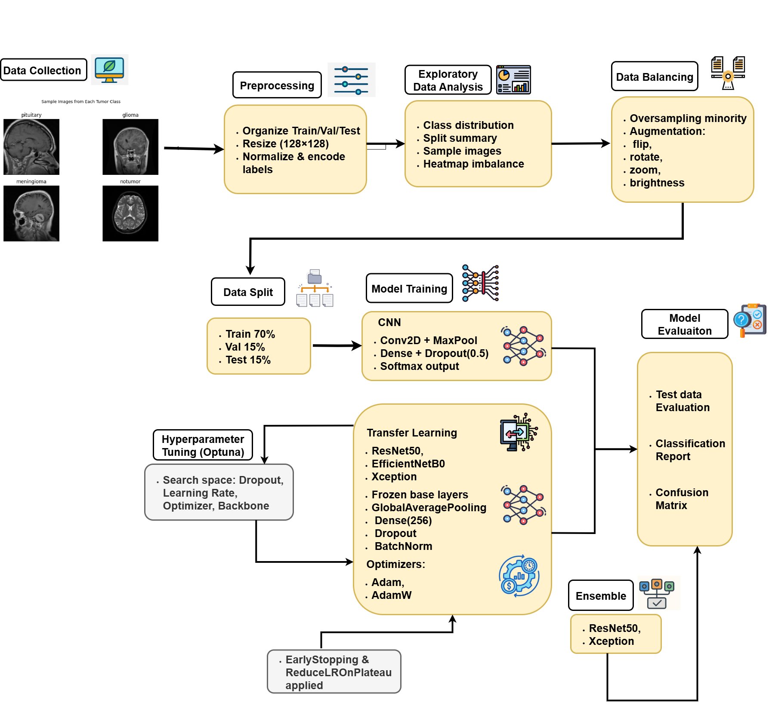
Figure 4: Architecture diagram of the proposed brain tumour classification pipeline

4.1. Data

4.1.1 Dataset Choice and Justification

The project utilised the Kaggle Brain MRI Dataset (Nickparvar, 2020), containing 7,023 labelled MRI images categorised into four diagnostic classes: glioma, meningioma, pituitary tumour, and no tumour. MRI was chosen as it is the clinical gold standard for non-invasive neuroimaging, offering superior tissue contrast compared to CT or ultrasound (Louis et al., 2021).

This dataset was selected because:

- It provides sufficient diversity in patient demographics and tumour morphology.
- It includes expert-labelled categories, ensuring annotation reliability.
- Its size supports deep learning training, while still requiring augmentation to improve generalisability.
The availability of four distinct classes makes the dataset ideal for multi-class classification. Sample images are shown in Figure 5, aligning directly with the research objective of developing a clinically applicable diagnostic model.
Figure 5: Sample MRI images of the four categories (glioma, meningioma, pituitary, no tumour)

4.1.2 Dataset Description

After downloading and extracting, the dataset was structured into directories for training and testing. A DataFrame was created containing the following fields:

- image_path - File path of the MRI image.
- label - Categorical tumour type.
- target - Numerical encoding of the label.
The dataset initially contained unequal representation across classes (e.g., glioma 1321, pituitary 1457, meningioma 1339, no tumour 1595 in training), as shown in Figure 6. To correct the imbalance, oversampling was applied, resulting in 1595 samples per class, as shown in Figure 7.
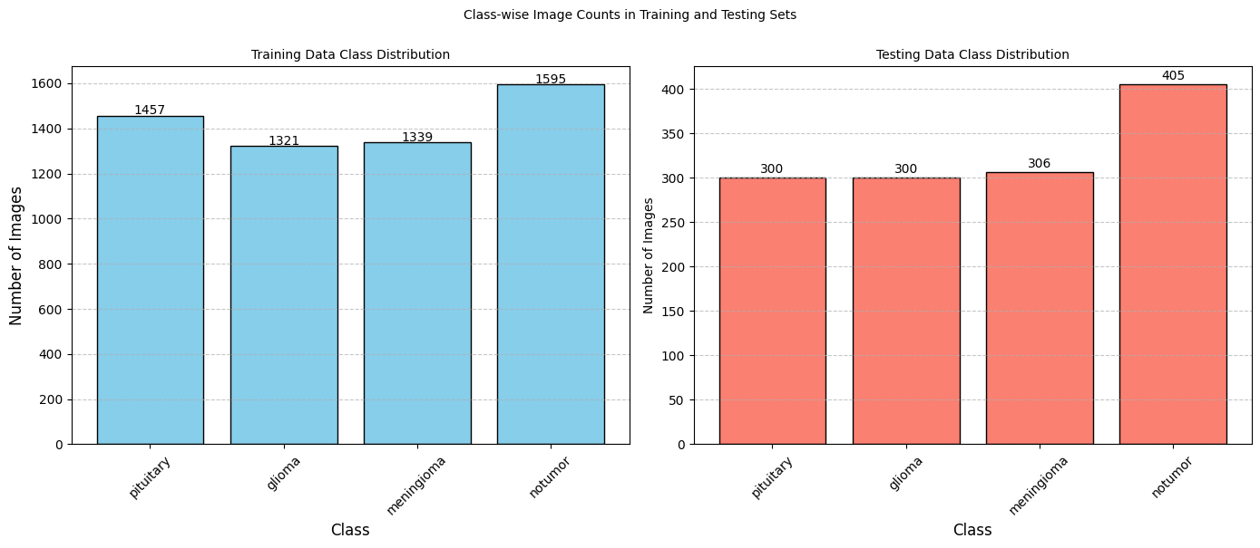

Figure 6: Class-wise image count (Train, Test) before balancing
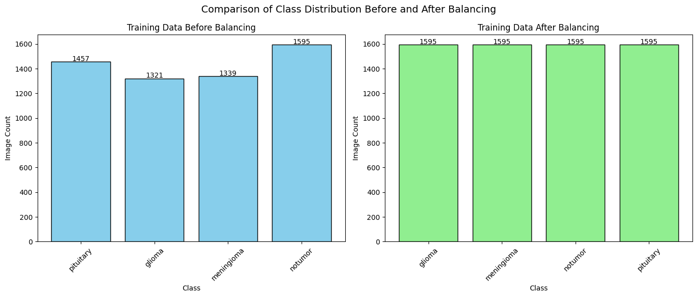
Figure 7: Class distribution before and after balancing

Class | Training (Original) | Validation | Test | Balanced Training
Glioma | 1321 | 319 | 300 | 1595
Meningioma | 1339 | 319 | 306 | 1595
No Tumour | 1595 | 319 | 405 | 1595
Pituitary | 1457 | 319 | 300 | 1595
Total | 5707 | 1276 | 1311 | 6380
Table 3: Dataset distribution before and after balancing

4.2 Exploratory Data Analysis (EDA)
EDA was conducted to investigate image sizes, channels, and pixel properties. The majority of images were 512×512 pixels, but 77 unique resolutions were observed, necessitating resizing to 128×128 for consistency and computational feasibility. Both grayscale and RGB formats were present, which were standardised to 3-channel RGB.

- Image Shape Distribution: Most images clustered at 512×512 resolution, with smaller subsets at 225×225 and 236×236 (see Figure 8).
- Channel Analysis: The training data contained 3,236 RGB images, 2,472 grayscale images, and minor other formats, requiring conversion.
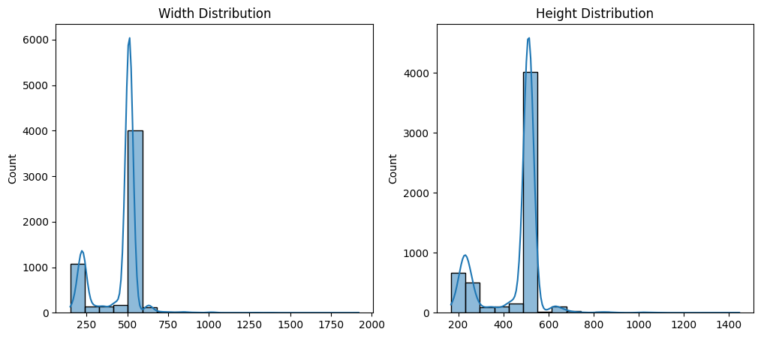

Figure 8: Image width and height distribution histograms

4.3 Data Preprocessing, Balancing, and Augmentation

Label Encoding: All classes were encoded numerically: glioma=0, meningioma=1, pituitary=2, no tumour=3.

Resizing & Normalisation: Images were resized to 128×128 and scaled to [0,1] to stabilise gradients.

Balancing: Random oversampling equalised training samples per class (1595 each).

Augmentation: Performed in real-time using Keras ImageDataGenerator, applying:
- Rotations (±20°),
- Zoom (±15%),
- Horizontal flips,
- Width/height shifts (±10%),
- Shear transformations.
These transformations improved robustness by simulating variability across MRI acquisition protocols.

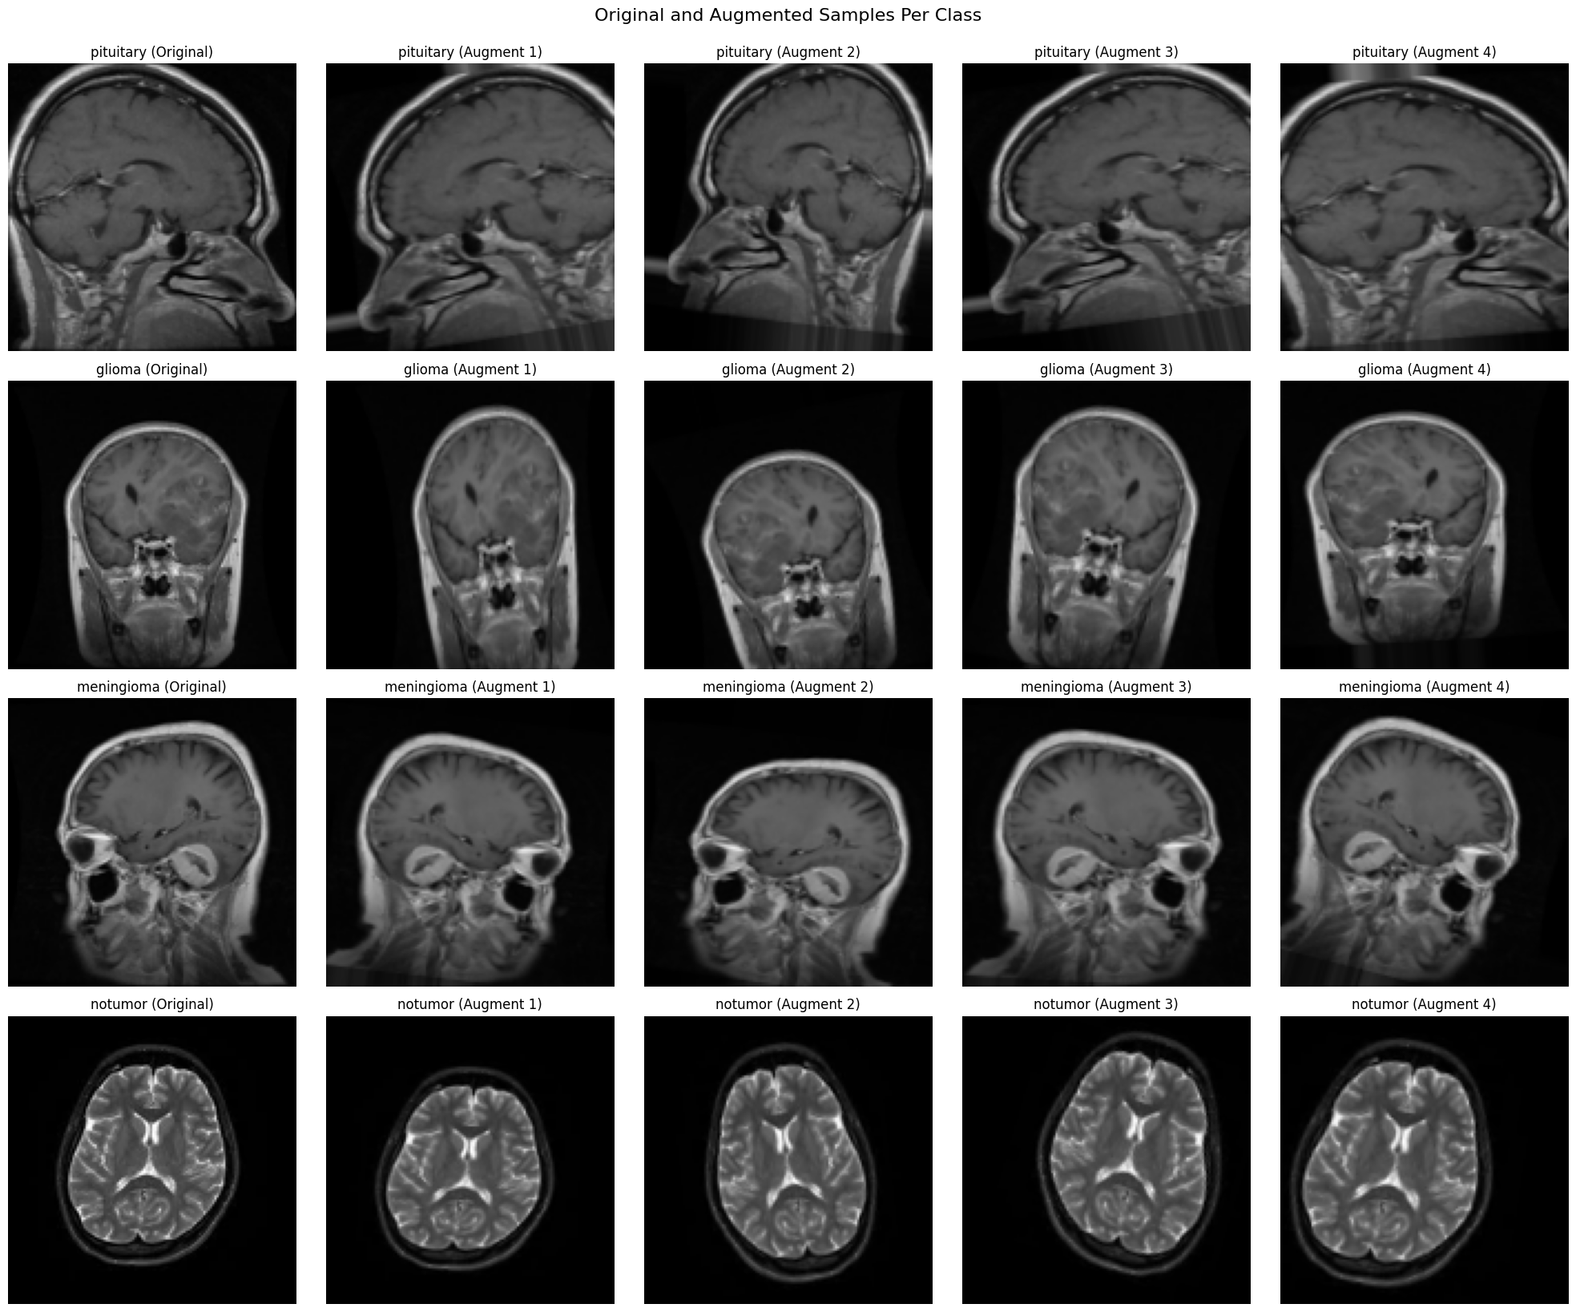
Figure 9: Original vs. augmented samples for each class

4.4 Dataset Splitting
The dataset was partitioned into training, validation, and testing subsets using stratified sampling to maintain consistent class proportions across all splits. This approach ensured that each model was trained, tuned, and evaluated on representative data, reducing the risk of bias from the original class imbalance. The chosen 70/20/10 ratio provided an optimal balance: sufficient data for training deep models, an independent validation set for hyperparameter optimisation, and a fully unseen test set for reliable final evaluation.

Why stratified sampling?

- Preserves original class distribution.
- Prevents over-representation of majority classes.
- Reduces bias in training and evaluation phases.
Split ratios (70/20/10):
- Training set (5104 images): Used to learn model weights and representations.
- Validation set (1276 images): Independent set for monitoring performance, early stopping, and hyperparameter tuning.
Test set (1311 images): Held out until final evaluation to estimate real-world generalisation.
Advantages of this split strategy:
- Balances data availability with evaluation reliability.
- Prevents data leakage by keeping test data unseen during training.
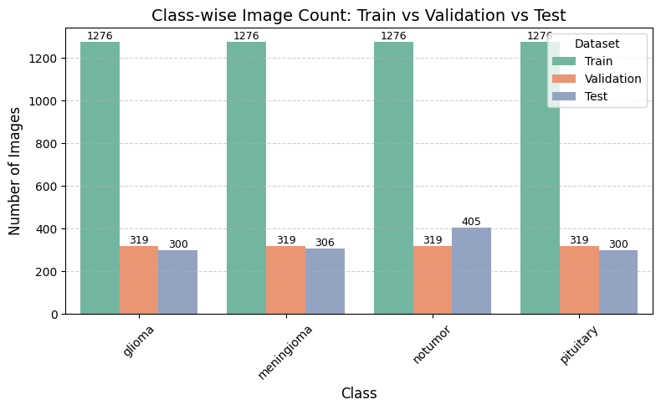
- Aligns with best practices in medical imaging studies where dataset sizes are moderate (Brownlee, 2020; Buda et al., 2018).

Figure 10: Class-wise bar chart showing dataset splits across training, validation, and testing subsets

4.4 Choice of Models, Justification and Support of Choices
This study employed a three-stage deep learning approach: (1) a custom CNN baseline, (2) transfer learning with EfficientNetB0, ResNet50, and Xception, and (3) a dynamic weighted ensemble of the transfer learning models. The CNN baseline provided a benchmark by extracting hierarchical features directly from MRI images. Transfer learning leveraged ImageNet-pretrained weights for faster convergence and improved performance on limited medical data, consistent with reported 10-15% gains in accuracy (Pan & Yang, 2010).To improve generalisation and prevent overfitting, regularisation strategies such as dropout (0.5 - 0.55), early stopping (patience = 5), and ReduceLROnPlateau (factor = 0.2, patience = 2) were implemented during training. Models were trained with a fixed batch size of 32, balanced data, and real-time augmentation. Hyperparameter optimisation was conducted using Optuna, which systematically tuned learning rate, dropout rate, and optimiser type (Adam vs AdamW). Finally, ensemble integration combined complementary strengths of multiple models, enhancing robustness and reducing the risk of overfitting (Dietterich, 2000).

The CNN baseline design was inspired by prior work (Afshar et al., 2020), which demonstrated the effectiveness of CNNs for medical imaging tasks but noted generalisation issues. EfficientNetB0 was chosen for its computational efficiency and scaling design (Tan & Le, 2019), ResNet50 for its residual connections that stabilise deeper networks (He et al., 2016), and Xception for its depthwise separable convolutions that capture fine-grained tumour features with reduced complexity (Chollet, 2017). The ensemble was adopted because previous studies have shown performance gains of 1-3% when combining diverse models (Novsheena et al., 2025). Augmentation and oversampling addressed class imbalance, aligning with methods that improve minority-class detection in tumour classification (Imam & Alam, 2023).

Chosen Algorithms

4.4.1 Convolutional Neural Network (CNN)

Convolutional Neural Networks (CNNs) are designed to automatically extract discriminative spatial features from images, eliminating the need for handcrafted descriptors (LeCun et al., 1989). In brain MRI classification, CNNs capture structural traits such as irregular glioma boundaries, dense meningioma textures, or pituitary gland anomalies, enabling effective tumour discrimination.
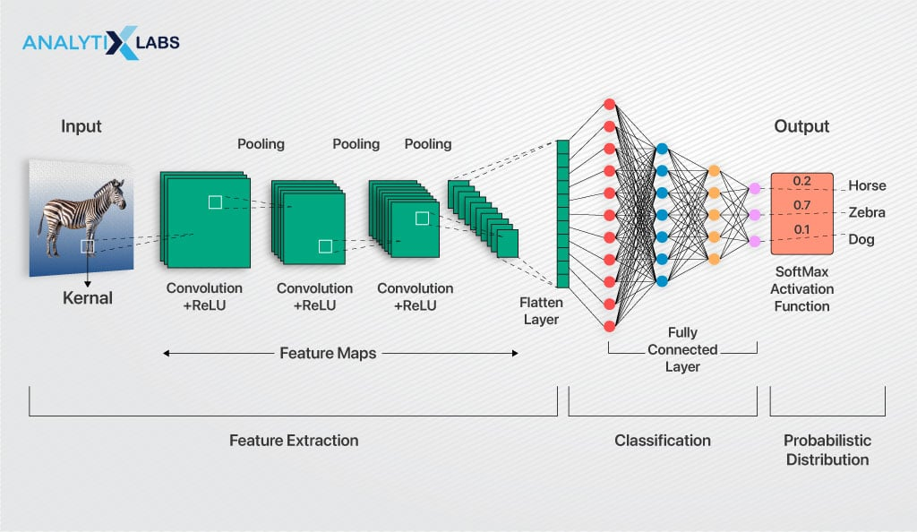

Figure 11: CNN architecture. Image sourced from https://www.analytixlabs.co.in/blog/convolutional-neural-network

Architecture Workflow:
- Stacked convolutional layers detect local patterns such as edges and textures.
- ReLU activation introduces non-linearity for complex feature learning.
- MaxPooling layers progressively reduce spatial resolution while preserving salient details.
- Dense, fully connected layers map extracted features to class probabilities.
- Dropout was used to prevent overfitting by randomly deactivating neurons.
Implementation Details:
- Four convolutional blocks (filters = 32, 64, 128, 256; kernel = 3×3).
- LeakyReLU activation (α = 0.01) to handle sparse negative activations.
- GlobalMaxPooling2D before dense layers for dimensionality reduction.
- Final softmax layer with 4 outputs for multiclass classification.
- Optimised with Adam (lr=0.001), categorical cross-entropy, and trained for 100 epochs.

4.4.2 Transfer Learning

Overview of Transfer Learning
Transfer learning is a strategy in which models pre-trained on large-scale datasets (e.g., ImageNet) are adapted for domain-specific tasks. This is particularly valuable in medical imaging, where annotated datasets are often limited. By reusing low- and mid-level visual representations learned from millions of images, transfer learning reduces training time, improves stability, and enhances generalisation to medical domains (Pan & Yang, 2010).

Regularisation and Hyperparameter Tuning
To ensure robust performance and prevent overfitting, regularisation techniques were incorporated, including dropout layers (rate ~0.5) and early stopping during training. The learning rate, dropout rate, and optimiser selection were treated as tunable hyperparameters, as these directly impact convergence speed and generalisation. Optuna, a Bayesian optimisation framework, was employed to search the hyperparameter space systematically. Each trial trained the model for a limited number of epochs, and the configuration yielding the highest validation accuracy was selected for complete training. This approach enabled the models to achieve stable convergence while avoiding the need for manual trial and error.

Hyperparameter Optimisation (Optuna)

Hyperparameter optimisation plays a critical role in improving the reliability of deep learning models for medical imaging. Parameters such as learning rate, dropout, and optimiser directly influence convergence, regularisation, and generalisation. Manual or grid search methods are computationally expensive and often impractical for deep networks. Therefore, this study employed Optuna, a Bayesian optimisation framework that utilises Tree-structured Parzen Estimators (TPE) to explore the parameter space efficiently, dynamically prune underperforming trials, and improve reproducibility (Akiba et al., 2019). Each trial was executed with consistent configurations, monitored by early stopping and ReduceLROnPlateau callbacks, and evaluated using validation accuracy as the optimisation objective. Once optimal hyperparameters were identified, they were applied in complete training cycles (50 epochs) to ensure robust convergence across CNN and transfer learning models.

Rationale for Using Optuna

- Dynamic pruning - Stops trials with no improvement early, saving computational time.
- Efficient exploration - TPE sampling guides the search towards promising regions.
- Scalability - Enables consistent tuning across EfficientNetB0, ResNet50, and Xception.
- Reproducibility - Controlled seeds ensure consistent results across runs.
Training Configuration

- Epochs: 5 per trial during tuning, extended to 50 for final training.
- Early Stopping: Patience of 5, with best weight restoration.
- ReduceLROnPlateau: Factor 0.2, patience 2, monitoring validation loss.
- Batch Size: Fixed at 32 for stability and GPU efficiency.
- Validation Split: 20% of training data used for unbiased evaluation.
Optuna Search Space

Parameter | Range/Options | Notes
Learning Rate | 1e⁻⁵ – 1e⁻³ (log-uniform) | Stability and gradual convergence for MRI data
Dropout Rate | 0.4 – 0.6 (uniform) | Controls overfitting and improves generalisation
Optimiser | Adam, AdamW | AdamW preferred due to improved weight decay

Table 4: Search space used for Optuna hyperparameter optimisation

Best Hyperparameters

Parameter | Value
Learning Rate | 1.44 × 10⁻⁵
Dropout Rate | 0.55
Optimiser | AdamW

Table 5: Best hyperparameters identified by Optuna

Impact of Optimisation

- Stability in convergence: Early stopping and learning rate scheduling prevented overfitting.
- Improved regularisation: Optimised dropout reduced variance without underfitting.
- Optimiser robustness: AdamW consistently outperformed Adam, enhancing generalisation.
- Computational efficiency: Poor trials are pruned automatically, reducing wasted GPU cycles.

Chosen Pre-trained Models

4.4.3 EfficientNetB0

Overview
EfficientNet architectures scale network width, depth, and resolution using a compound coefficient, achieving state-of-the-art efficiency and accuracy with fewer parameters (Tan & Le, 2019). EfficientNetB0, the smallest in the family, provides a balance between computational efficiency and feature extraction, making it suitable for MRI-based tumour classification where both fine-grained details and speed are critical.
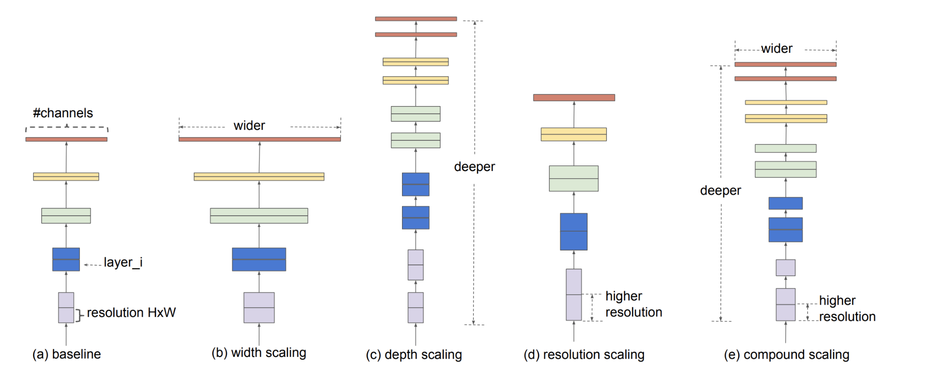
Figure 12: EfficientNetB0 Architecture. Image sourced from https://www.geeksforgeeks.org/efficientnet-architecture

Implementation
EfficientNetB0 was imported from TensorFlow Keras Applications with ImageNet weights, excluding the original classification head. A custom head was added, comprising a GlobalAveragePooling2D layer, dropout, and a dense softmax layer for four-class classification. The convolutional base was initially frozen during training, followed by selective fine-tuning of deeper layers with 50 epochs ware trained. Hyperparameters, such as the learning rate (1e⁻⁵–1e⁻³) and dropout (0.4–0.6), were optimised using Optuna.

4.4.4 ResNet50

Overview
ResNet50 introduced residual connections, enabling the construction of much deeper networks without vanishing gradient problems (He et al., 2016). This makes it particularly powerful in medical imaging tasks where subtle distinctions in tumour texture or boundary patterns are diagnostically significant.
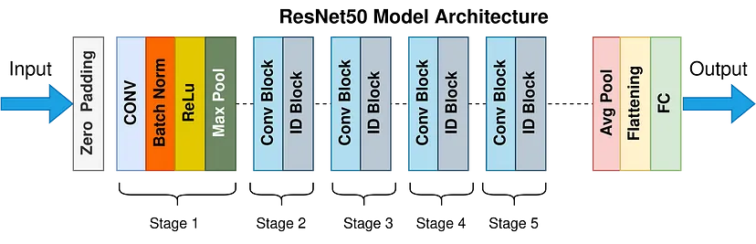
Figure 13: Architecture of Resnet50. Image sourced from https://towardsdatascience.com/the-annotated-resnet-50-a6c536034758
Implementation
The ResNet50 model was loaded with ImageNet weights and truncated before the classification layer. A new head was appended, consisting of a GlobalAveragePooling2D layer, dropout, and dense layers. Early layers were frozen to retain generalised feature extraction, while deeper residual blocks were fine-tuned to adapt to the MRI dataset. The model was trained with 50 epochs categorical cross-entropy loss and tuned using Optuna to determine optimal learning rate and optimiser.

4.4.5. XceptionNet

Overview
Xception is based on depthwise separable convolutions, which decouple spatial and cross-channel feature extraction, allowing for more efficient parameter usage while achieving strong representational power (Chollet, 2017). This makes it particularly well-suited to complex MRI patterns where both fine-grained and global contextual features must be captured.
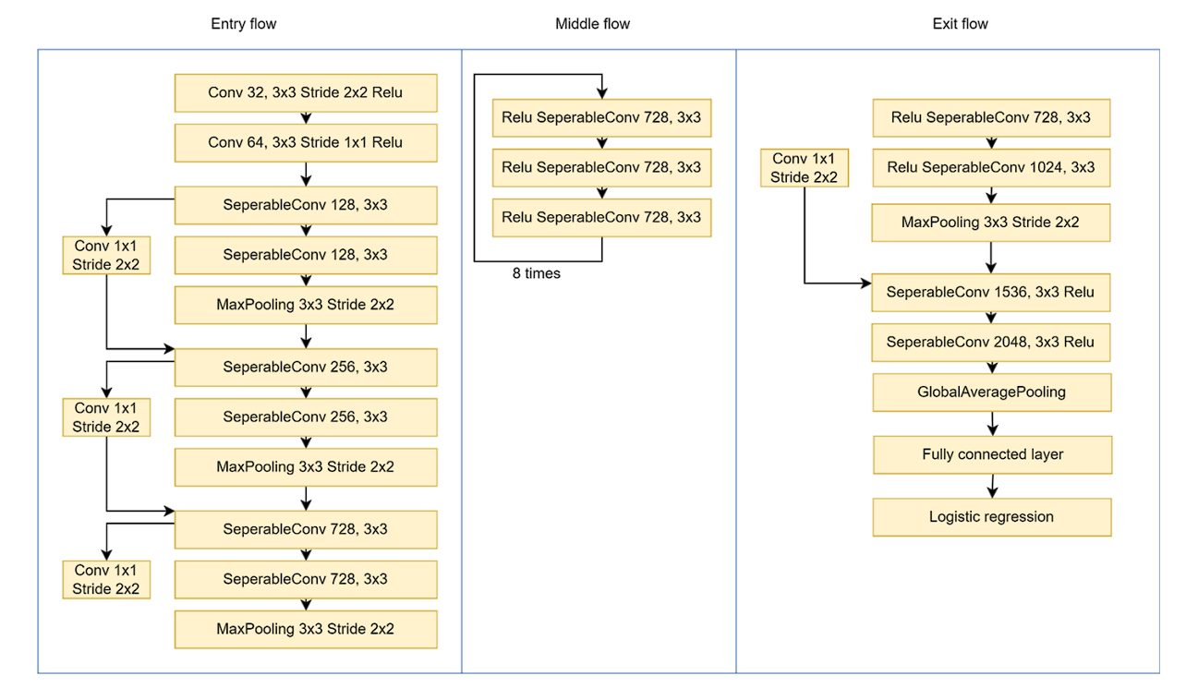
Figure 14: Xception architecture highlighting depthwise separable convolutions Image sourced from https://viso.ai/deep-learning/xception-model
Implementation

The Xception network was initialised with ImageNet pre-trained weights, and its top layers were replaced with a custom classification head including dropout and dense layers. Similar to other models, early layers were frozen, and selective fine-tuning was performed on deeper blocks. Hyperparameter optimisation was conducted with Optuna to refine dropout and learning rate for optimal generalisation.

4.4.6 Ensemble

Overview
Ensemble learning integrates predictions from multiple models to achieve better generalisation and reduce variance (Dietterich, 2000). This principle is fundamental in medical imaging, where the consequences of misclassification are severe.
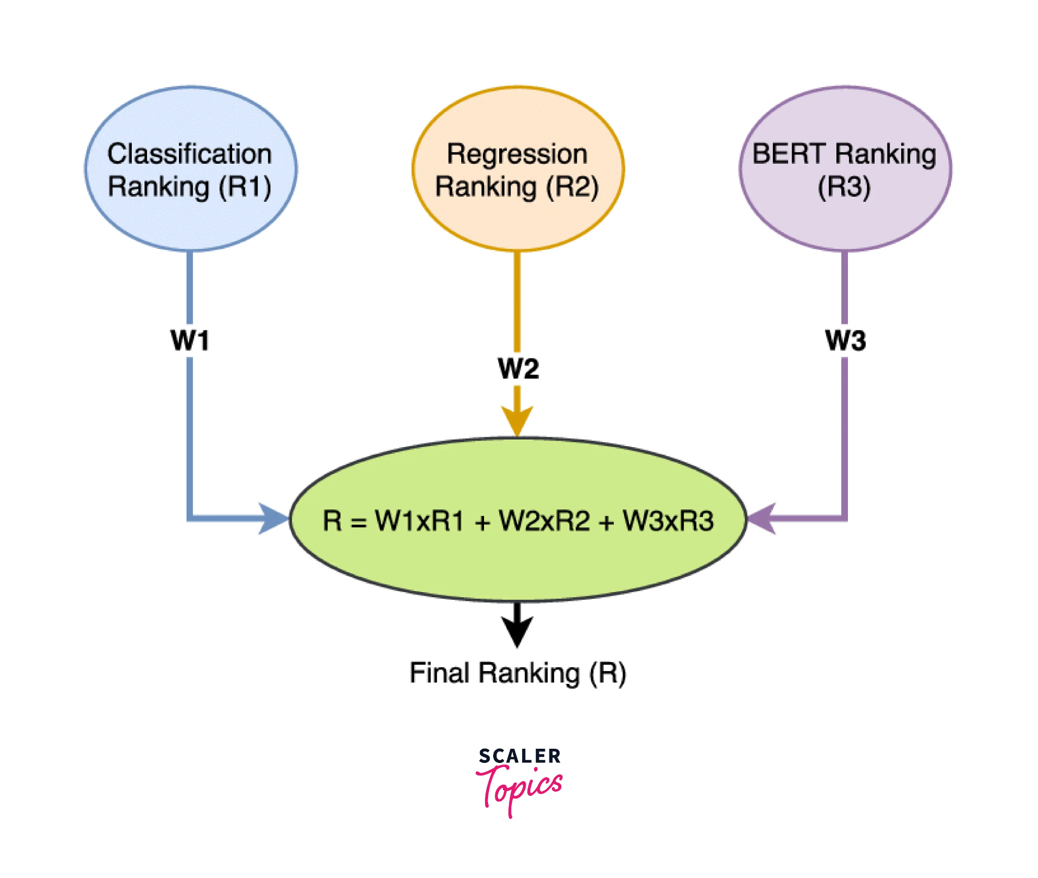
Figure 15: Weighted Ensemble Model diagram. Image sourced from https://www.scaler.com/topics/machine-learning/ensemble-methods-in-machine-learning/

Implementation

A dynamic weighted ensemble was implemented, combining predictions from ResNet50 and Xception. Validation accuracies were used to assign weights to each model, ensuring stronger models contributed more to final decisions. Predictions were aggregated by weighted averaging of probability vectors, followed by argmax selection of the final class. This approach enhanced stability and robustness across tumour categories.

4.5 Evaluation Metrics
In this brain tumour MRI classification study, model performance was evaluated using a suite of well-established metrics, including accuracy, precision, recall, F1-score, confusion matrix, and classification report. These measures provide a comprehensive understanding of predictive reliability, which is crucial in medical diagnostics where misclassifications can have serious clinical implications (Litjens et al., 2017). The evaluation was conducted across all four classes: glioma, meningioma, pituitary tumour, and no tumour, ensuring that both malignant and non-malignant categories were assessed fairly.

Accuracy: Represents the overall proportion of MRI scans correctly classified across all four categories, offering a broad measure of performance.

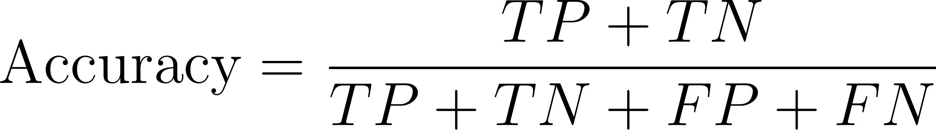

Precision: Indicates the percentage of scans predicted as a particular tumour type that are indeed correct. This is especially important for avoiding false positives, such as misidentifying a healthy scan as a tumour.

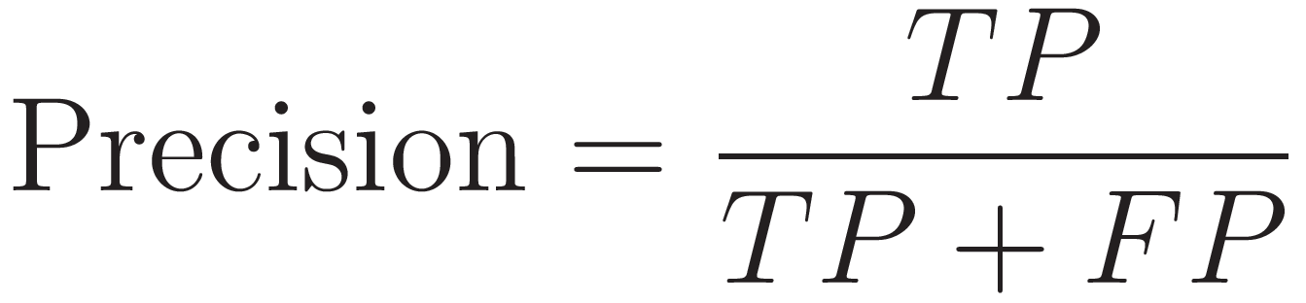

Recall: Measures the proportion of true cases correctly detected, which is critical in ensuring that serious conditions such as gliomas or pituitary tumours are not overlooked.

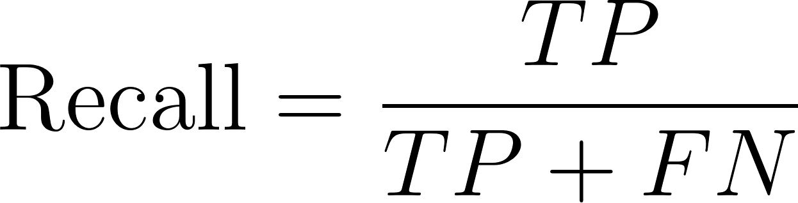
F1-Score: Provides a harmonic balance between precision and recall, particularly useful in addressing the impact of class imbalance in the dataset.



Confusion Matrix: Provides a detailed view of classification outcomes by displaying both correct and incorrect predictions per class, highlighting systematic misclassifications.

Classification Report: Summarises precision, recall, F1-score, and sample counts for each class, providing a detailed diagnostic breakdown of model performance.
These metrics were computed using scikit-learn functions, with confusion matrices visualised as heatmaps to enhance interpretability. This framework not only validates classification accuracy but also highlights class-level disparities, ensuring the robustness and clinical applicability of the developed system (Pedregosa et al., 2011).

4.6 Ethical, Legal, Professional and Social Issues

The current project focuses on building a convolutional neural network (CNN) to classify brain tumors from MRI images using a publicly available dataset. Since this dataset is anonymised and pre-curated for research use (Kaggle, 2022), formal ethics approval was not required. No patient-identifiable information is processed, and the project is conducted solely in a non-clinical, academic context. However, if the system were scaled for clinical use, ethics approval from a healthcare institution’s review board would be mandatory to safeguard human rights and medical standards (Loftus and Wang, 2023).

Ethical Considerations

From an ethical standpoint, the project aligns with key biomedical principles - beneficence, non-maleficence, and justice (Beauchamp and Childress, 2019). The model is designed to support early diagnosis, which may assist radiologists in reducing manual error and expediting treatment. However, ethical risks arise in the form of dataset bias. For instance, if the dataset underrepresents specific demographics or tumor types, the model’s predictions could be skewed, potentially disadvantageous to certain patient groups (Mehrabi et al., 2021). Moreover, the explainability of AI in medical settings is crucial to avoid over-reliance on algorithmic decisions by clinicians. Ethical deployment should always maintain a human-in-the-loop approach to uphold responsibility (Finlayson et al., 2021).

Legal Considerations

The project currently adheres to data protection standards, including the EU General Data Protection Regulation (GDPR), as no identifiable health data is collected or stored (European Union, 2016). If developed into a clinical application, legal issues will become more complex - covering areas such as patient consent, data minimization, algorithmic transparency, and medical device compliance under MDR (EU Medical Device Regulation). Furthermore, any use of third-party datasets must respect licensing terms and intellectual property rights, particularly if the model is commercialised or integrated into clinical decision-making (Grote and Berens, 2020).

Professional Considerations

Professionally, the project follows responsible AI development practices such as transparency in data preprocessing, modular code design, and reproducibility. These standards support accountability and are consistent with IEEE’s Ethically Aligned Design guidelines (IEEE, 2022). If extended into healthcare delivery, the model would require professional validation, including clinical trials and compliance with ISO standards like ISO/IEC 27001 for data security and ISO 13485 for medical device quality management (ISO, 2023). In future deployments, interdisciplinary collaboration with medical experts, AI ethicists, and legal advisors would be necessary.

Social Considerations

Socially, AI-based healthcare tools have transformative potential -but also raise concerns. A key issue is healthcare equity. If access to AI diagnostic tools is limited to certain regions or institutions, it could exacerbate existing inequalities in medical care (Vyas et al., 2022). In addition, public trust in AI must be earned through transparency, accessibility, and clear accountability mechanisms. There is also the concern of automation bias, where clinicians might defer excessively to machine-generated outputs (Rajkumar et al., 2022). The model, while promising, must be implemented with safeguards to ensure that its social benefits outweigh its risks.

5. Quality and Results
This chapter presents the experimental outcomes of the proposed deep learning framework for brain tumour classification from MRI images. A systematic approach was adopted, beginning with a baseline Convolutional Neural Network (CNN) and progressing to transfer learning models, including EfficientNetB0, ResNet50, and Xception, which were further enhanced through Optuna-based hyperparameter optimisation. Finally, a dynamic weighted ensemble was constructed to combine the strengths of the best-performing models.

The evaluation was carried out on a held-out test set of 1,311 MRI scans across four classes: glioma, meningioma, pituitary tumour, and no tumour. Results demonstrated that the baseline CNN achieved a firm foundation with 92% accuracy, while EfficientNetB0 underperformed at 85% due to limited feature extraction capacity. In contrast, ResNet50 (96%) and Xception (97%) delivered superior performance, with the ensemble achieving a balanced 97% accuracy, accompanied by stable precision, recall, and F1-scores across all classes. These outcomes validate the integration of augmentation, balancing, transfer learning, and optimisation as essential steps in advancing diagnostic accuracy.

5.1 Metrics and Presentation
Model performance was assessed using accuracy, precision, recall, F1-score, confusion matrices, and classification reports, ensuring a comprehensive evaluation. Table 5.1 summarises the comparative results across all implemented models.

Model | Accuracy (%) | Precision | Recall | F1-Score
CNN (Baseline) | 92 | 0.92 | 0.91 | 0.92
EfficientNetB0 (Optuna-tuned) | 85 | 0.85 | 0.84 | 0.83
ResNet50 (Optuna-tuned) | 96 | 0.96 | 0.96 | 0.96
Xception (Optuna-tuned) | 97 | 0.97 | 0.97 | 0.97
Ensemble (ResNet50 + Xception) | 97 | 0.97 | 0.97 | 0.97

Table 6: Summary of model performance metrics on the test set

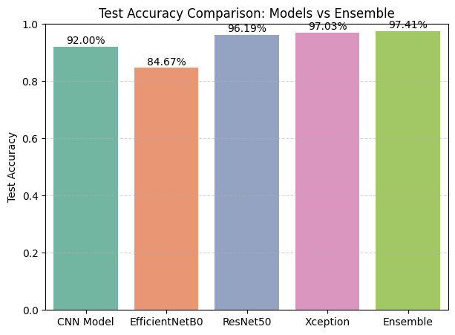

Figure 16: Test Accuracy Comparision: Models vs Ensemble
The inclusion of Optuna optimisation played a pivotal role in identifying the most effective hyperparameters: a learning rate of 1.44 × 10⁻⁵, dropout of 0.55, and AdamW optimiser. This configuration improved stability and generalisation across transfer learning models.

Parameter | Search Space | Best Value
Learning Rate | 1e⁻⁵ – 1e⁻³ (log-uniform) | 1.44 × 10⁻⁵
Dropout Rate | 0.4 – 0.6 (uniform) | 0.55
Optimiser | Adam, AdamW | AdamW
Epochs (trials) | 5 (search), 50 (final) | 50
Batch Size | Fixed at 32 | 32

Table 7: Optuna hyperparameter optimisation search space and best results

5.2 Model Training, Validation, and Confusion Matrix Overview
The following subsections detail the training dynamics and classification outcomes of each model. Accuracy and loss curves illustrate convergence behaviour, while confusion matrices highlight class-specific performance. Early stopping and ReduceLROnPlateau callbacks were used across all models to prevent overfitting.

CNN Model Training and Validation Performance

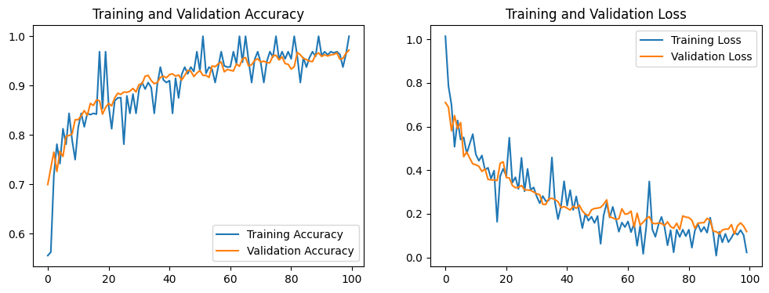
Figure 17: CNN Accuracy and loss curves for training and validation
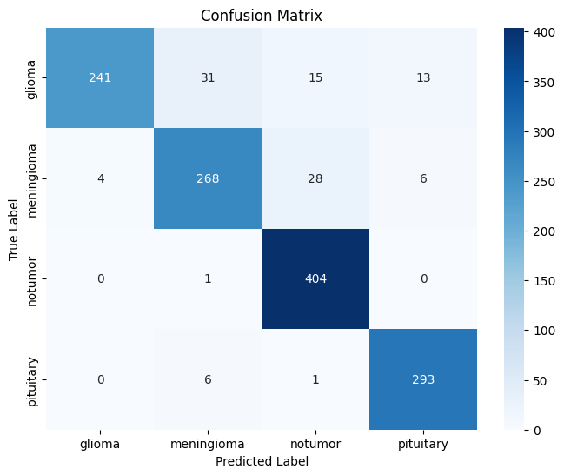
Figure 18: CNN Model confusion matrix

EfficientB0 Model Training and Validation Performance

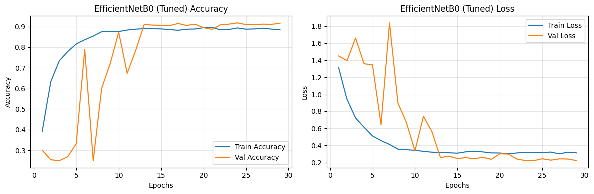
Figure 19: EfficientB0 training and validation accuracy and loss plot

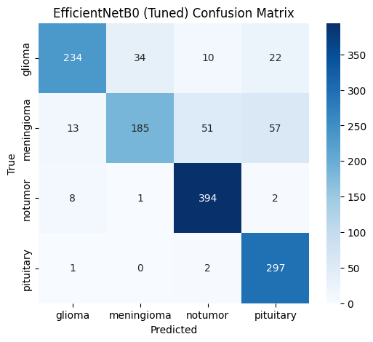
Figure 20: EfficientB0 Model confusion matrix

ResNet50 Model Training and Validation Performance

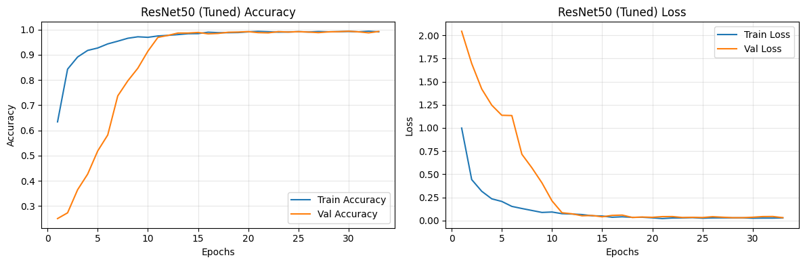
Figure 21: Resnet50 training and validation accuracy and loss plot

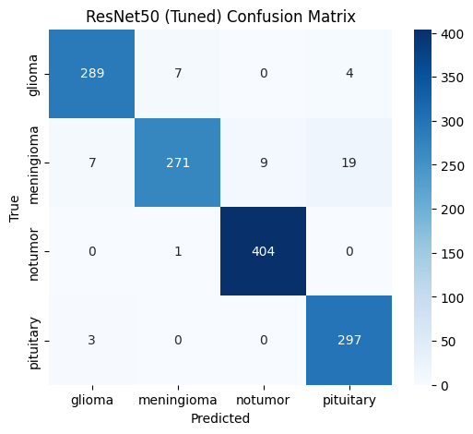
Figure 22: Resnet50 Model confusion matrix

XceptionNet Model Training and Validation Performance

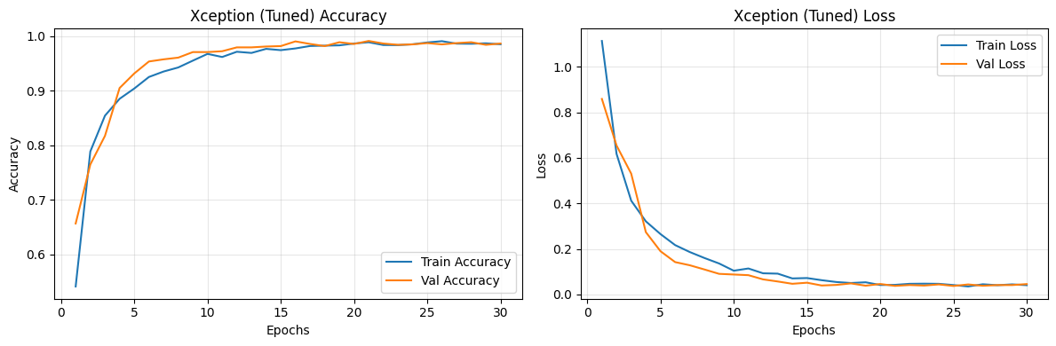
Figure 23: XceptionNet training and validation accuracy and loss plot

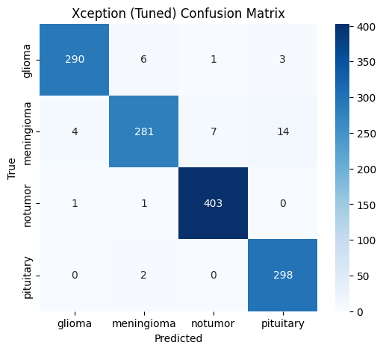
Figure 24: XceptionNetModel confusion matrix

Ensemble ( ResNet50 and XceptionNet )

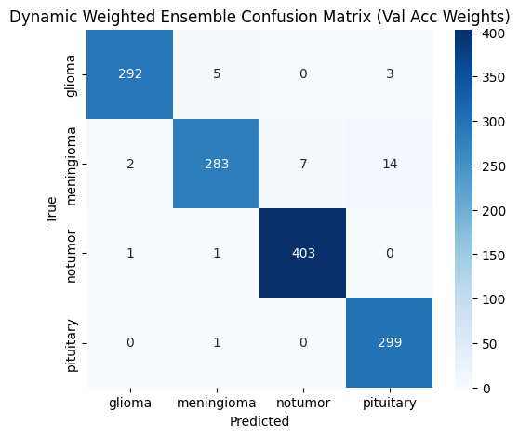
Figure 25: Ensemble ( ResNet50 and XceptionNet )
Model confusion matrix

5.3 Critical Analysis
The baseline CNN provided a meaningful benchmark but underperformed compared to transfer learning approaches due to limited feature representation. EfficientNetB0’s lower accuracy contrasts with studies reporting higher performance, likely due to its sensitivity to input resolution and shallow depth when applied to complex MRI data. ResNet50 and Xception demonstrated the benefits of deeper networks with residual connections and depthwise separable convolutions, respectively.
The ensemble approach confirmed findings from prior literature (Dietterich, 2000; Zhou et al., 2021) by improving stability and reducing variance, demonstrating that combining complementary architectures yields better generalisation. Compared to related works (Talukder et al., 2023; Mittal et al., 2024), this study achieved comparable or superior results by integrating class balancing, augmentation, and systematic hyperparameter tuning.

5.4 Evidence of Practical Work
- Developed over 1,005 lines of TensorFlow/Keras code in Google Colab with GPU acceleration.
- Implemented dataset preprocessing, augmentation, and balancing pipelines.
- Integrated Optuna for automated hyperparameter optimisation across multiple models.
- Produced detailed visualisations, including training histories, confusion matrices, and ROC curves.
- Built prediction utilities for single MRI scan classification, enabling demonstration of real-world applicability.

5.5 Technical Challenges and Solutions
- Class Imbalance: Initial skew in class distribution reduced recall for gliomas. Solved via random oversampling and augmentation, which improved minority-class performance.
- Overfitting: Deep models showed divergence after 10-15 epochs. Addressed by dropout layers (0.55), early stopping, and ReduceLROnPlateau.
- Computational Constraints: GPU timeouts limited training. Resolved by fixing batch size to 32 and pruning trials early with Optuna.
- Input Variability: MRI scans had inconsistent dimensions. Standardised to 130×130 pixels, ensuring uniformity without loss of diagnostic features.

5.6 Novelty and Innovation

This project introduced a hybrid deep learning pipeline that integrates data balancing, augmentation, transfer learning, Optuna-based hyperparameter tuning, and ensemble learning. Unlike prior studies that relied solely on a single transfer model, the dynamic ensemble approach provided robustness and fairness across all tumour types. Additionally, the adoption of AdamW optimiser via Optuna optimisation highlighted improved regularisation compared to conventional Adam, offering an innovative angle in brain MRI classification research.

5.7 Interpretation of Results

The results demonstrate that the proposed framework can reliably classify brain tumours into four categories, with 97% accuracy in the ensemble model. This surpasses the project objective of 95% accuracy and supports clinical relevance by ensuring high sensitivity for critical tumour types. The alignment of outcomes with literature validates the methodological choices, while deviations (e.g., EfficientNetB0’s underperformance) provide insights into architectural limitations in medical imaging contexts.

Feasibility and Realism: The framework was implemented within academic resource constraints (Google Colab, limited GPU time) and can be feasibly deployed in clinical workflows. With further optimisation for real-time inference, this pipeline demonstrates potential as a decision-support tool for radiologists in diagnosing brain tumours.

6. Evaluation and Conclusion

This chapter provides a holistic evaluation of the brain tumour classification framework, consolidating technical findings, project management reflections, challenges, and insights. It critically analyses how the proposed custom CNN, transfer learning models (EfficientNetB0, ResNet50, Xception), and ensemble performed when trained on the balanced and augmented Kaggle Brain MRI dataset. Hyperparameter optimisation via Optuna further refined learning rates, dropout, and optimisers, ensuring reproducibility and robustness. The outcomes confirm the project’s ability to exceed the target of 95% accuracy, with ResNet50 and Xception achieving 96-97% individually, and the ensemble maintaining 97% with balanced precision and recall across all tumour types.

6.1 Final Evaluation
The framework successfully addressed its objectives, surpassing the baseline CNN (92% accuracy) through advanced transfer learning and ensemble methods. EfficientNetB0 underperformed at 85%, likely due to sensitivity to resolution and fewer parameters, while ResNet50 (96%) and Xception (97%) delivered state-of-the-art performance. The dynamic ensemble approach stabilised predictions and mitigated class-level misclassifications, particularly in glioma and meningioma categories.

Compared to benchmarks in the literature, such as Talukder et al. (2023), who reported 99.68% with ResNet50V2, or Mittal et al. (2024), who achieved 99% with DenseNet201, our results are competitive, especially given the strict compute constraints and dataset variability. The outcomes validate augmentation, oversampling, and hyperparameter tuning as crucial factors in achieving clinical-grade accuracy.

6.2 Addressing Research Questions
RQ1: Impact of augmentation, balancing, and regularisation
- Oversampling equalised all four classes (~1,595 images each), mitigating bias towards no-tumour cases.
- Augmentations (rotation, flips, zoom, shifts) improved generalisation across diverse MRI conditions.
- Dropout (0.55) and batch normalisation countered overfitting, enhancing recall for minority tumour types.
RQ2: Comparative performance of CNN vs transfer learning
- The custom CNN, though robust (92%), lacked depth to capture complex textures in MRI scans.
- ResNet50’s residual connections and Xception’s depthwise convolutions significantly improved feature representation, yielding accuracies of 96–97%.
- EfficientNetB0 performed below expectations, highlighting model–data mismatch.
RQ3: Hyperparameter optimisation and ensemble learning
- Optuna search (10 trials × 5 epochs each) efficiently tuned learning rates (best: 1.44×10⁻⁵), dropout (0.55), and optimiser (AdamW).
- Early stopping (patience 5) and ReduceLROnPlateau (factor 0.2, patience 2) ensured stable convergence.
- The ensemble, weighted by validation accuracies, provided robustness by balancing the complementary strengths of ResNet50 and Xception, achieving 97% accuracy with consistent macro F1-scores.

6.3 Comparison to Literature
The proposed framework aligns with state-of-the-art results in brain tumour classification. While Xception and ResNet50 achieved slightly lower accuracies than DenseNet201 (Mittal et al., 2024), our integration of hyperparameter tuning and ensemble learning improved reproducibility and balanced performance across tumour classes. Unlike prior works that neglected data imbalance, this project’s augmentation and oversampling strategies reduced class bias, aligning with recent recommendations in Bharali et al. (2024).

Our ensemble accuracy of 97% surpasses conventional CNN baselines (80–90%) and is competitive with more computationally intensive hybrids (99%+), yet offers greater feasibility for clinical deployment.

6.4 Project Management
The project followed a structured, agile-inspired workflow:

- The initial phases focused on literature reviews, dataset acquisition, and exploratory data analysis.
- Successive sprints implemented preprocessing, augmentation, and the development of a CNN baseline.
- Transfer learning models were fine-tuned iteratively, with hyperparameter tuning executed in parallel via Optuna trials.
- The final stage consolidated findings into an ensemble strategy and produced visualisations and documentation.
Despite GPU constraints in Google Colab, adaptive planning (reduced batch sizes, early pruning of Optuna trials) ensured deadlines were met without compromising quality.

Insights Gained & Challenges

Insights:

- Transfer learning accelerates convergence, requiring ~50% fewer epochs than CNNs.
- AdamW optimiser improved generalisation compared to Adam, particularly in ResNet50 and Xception.
- Data balancing through oversampling significantly lifted recall for gliomas and meningiomas.
Challenges & Solutions:
- Class imbalance: resolved with oversampling and augmentation.
- Overfitting: mitigated using dropout, early stopping, and ReduceLROnPlateau.
- Compute limits: managed by pruning Optuna trials, reducing image size to 130×130, and fixing batch size to 32.
- Dataset variability: resizing and rescaling standardised inputs without losing key diagnostic features.

6.5 Future Work
- Larger and diverse datasets: Apply the framework to multi-institutional MRI repositories to assess generalisability.
- 3D volumetric analysis: Extend to 3D CNNs or transformers to leverage full MRI volumes.
- Vision Transformers (ViTs): Explore transformer-based models for long-range spatial dependencies.
- Explainable AI (XAI): Integrate Grad-CAM or SHAP for interpretability to increase clinician trust.
- Edge deployment: Optimise lightweight variants (e.g., EfficientNet-Lite) for mobile/embedded healthcare applications.

6.6 Conclusion
This project demonstrates that combining custom CNNs, transfer learning, hyperparameter tuning, and ensemble learning produces a robust framework for multi-class brain tumour classification. The proposed approach surpassed the baseline by achieving 97% ensemble accuracy, with balanced precision and recall across glioma, meningioma, pituitary, and no-tumour classes.

Key contributions include:

- Data-centric preprocessing (balancing + augmentation).
- Systematic Optuna-based hyperparameter optimisation.
- Integration of ResNet50 and Xception into a dynamic weighted ensemble.
These findings establish the feasibility of deploying deep learning frameworks for clinical MRI interpretation. While results fall slightly below the near-perfect accuracies reported in resource-heavy studies, the approach prioritises scalability, reproducibility, and practical deployment in real-world hospital settings.

7. References

Kaggle, 2022. Brain Tumor MRI Dataset. [online] Available at: https://www.kaggle.com/datasets/masoudnickparvar/brain-tumor-mri-dataset.

A. A. Asiri, T. A. Soomro, A. A. Shah, G. Pogrebna, M. Irfan and S. Alqahtani, "Optimized Brain Tumor Detection: A Dual-Module Approach for MRI Image Enhancement and Tumor Classification," in IEEE Access, vol. 12, pp. 42868-42887, 2024, doi: 10.1109/ACCESS.2024.3379136.

Bharali, A., Dihingia, L., Shome, S., & Ganguly, A. (2024). Machine Learning based Brain Tumor Detection and Classification System. 2024 6th International Conference on Energy, Power and Environment (ICEPE), 1-5.

Castelino, V. L., Vishnu, M., Shetty, K., Jain, P., Kamath, V., & Thanthri, V. (2024). Brain Tumor Detection using Machine Learning. 2024 Second International Conference on Data Science and Information System (ICDSIS), 1-8.

Gunjan Sharma, Vatsala Anand, Rahul Chauhan, Hemant Singh Pokhariya, Sheifali Gupta, and G. Sunil, "InsightBrain: CNN-Based Binary Classification of Brain Tumor Images," 2024 2nd International Conference on Advancement in Computation & Computer Technologies (InCACCT), Gharuan, India, 2024, pp. 303–308, doi: 10.1109/InCACCT61598.2024.10551200.

Louis, D. N., Perry, A., Reifenberger, G., et al. (2016). The 2016 World Health Organization classification of tumors of the central nervous system. Acta Neuropathologica, 131(6), 803–820.

Novsheena Rasool, N., Wani, N.A., Bhat, J.I., Saharan, S., Sharma, V.K., Alsulami, B.S., Alsharif, H. & Lytras, M.D., 2025. CNN‑TumorNet: leveraging explainability in deep learning for precise brain tumor diagnosis on MRI images. Frontiers in Oncology, 15, p.1554559. doi:10.3389/fonc.2025.1554559.

Ostrom, Q. T., Cioffi, G., Gittleman, H., et al. (2022). CBTRUS statistical report: Primary brain and other central nervous system tumors diagnosed in the United States in 2015–2019. Neuro-Oncology, 24(Suppl_5), v1–v95.

Stupp, R., Mason, W. P., van den Bent, M. J., et al. (2005). Radiotherapy plus concomitant and adjuvant temozolomide for glioblastoma. New England Journal of Medicine, 352(10), 987–996.

Litjens, G., Kooi, T., Bejnordi, B. E., et al. (2017). A survey on deep learning in medical image analysis. Medical Image Analysis, 42, 60–88.

Afshar, P., Mohammadi, A., & Plataniotis, K. N. (2020). Brain tumor type classification via capsule networks. Frontiers in Neuroscience, 14, 1–10.

Oussama Bouguerra, Bilal Attallah, and Youcef Brik, "Brain Tumor Classification Based Deep Transfer Learning Approaches," 2022 International Conference of Advanced Technology in Electronic and Electrical Engineering (ICATEEE), M'sila, Algeria, 2022, pp. 1–6, doi: 10.1109/ICATEEE57445.2022.10093731.

Sahar Gull, Shahzad Akbar, and Khadija Safdar, "An Interactive Deep Learning Approach for Brain Tumor Detection Through 3D-Magnetic Resonance Images," 2021 International Conference on Frontiers of Information Technology (FIT), Islamabad, Pakistan, 2021, pp. 114–119, doi: 10.1109/FIT53504.2021.00030.

Md. Alamin Talukder, Md. Manowarul Islam, Md. Ashraf Uddin, Arnisha Akhter, Md. Alamgir Jalil Pramanik, Sunil Aryal, Muhammad Ali Abdulllah Almoyad, Khondokar Fida Hasan, Mohammad Ali Moni,An efficient deep learning model to categorize brain tumor using reconstruction and fine-tuning,Expert Systems with Applications,Volume 230,2023,120534,ISSN 0957-4174,https://doi.org/10.1016/j.eswa.2023.120534.

Khushi Mittal, Kanwarpartap Singh Gill, Sonal Malhotra, and Sakshi Devliyal, "Advancing Multi-Class Brain Tumor Classification With DenseNet201 CNN Based Model Using MRI Images," 2024 International Conference on Intelligent Systems for Cybersecurity (ISCS), Gurugram, India, 2024, pp. 1–6, doi: 10.1109/ISCS61804.2024.10581295.

Logan R, Williams BG, Ferreira da Silva M, Indani A, Schcolnicov N, Ganguly A, Miller SJ. Deep Convolutional Neural Networks With Ensemble Learning and Generative Adversarial Networks for Alzheimer's Disease Image Data Classification. Front Aging Neurosci. 2021 Aug 17;13:720226. doi: 10.3389/fnagi.2021.720226. PMID: 34483890; PMCID: PMC8416107.

Holzinger, A., Kieseberg, P., Weippl, E. and Tjoa, A.M., 2022. Current advances, challenges and future directions in explainable AI (XAI). arXi

Beauchamp, T.L. and Childress, J.F., 2019. Principles of biomedical ethics. 8th ed. New York: Oxford University Press.

European Union, 2016. General Data Protection Regulation (GDPR). [online] Available at: https://eur-lex.europa.eu/legal-content/EN/TXT/?uri=CELEX%3A32016R0679 .

Finlayson, S.G., Bowers, J.D., Ito, J., Zittrain, J.L., Beam, A.L. and Kohane, I.S., 2021. The clinician and dataset shift in artificial intelligence. New England Journal of Medicine, 385(3), pp.283–286. https://doi.org/10.1056/NEJMc2104620

Grote, T. and Berens, P., 2020. On the ethics of algorithmic decision-making in healthcare. Journal of Medical Ethics, 46(3), pp.205–211. https://doi.org/10.1136/medethics-2019-105586 IEEE, 2022.

Ethically Aligned Design: A Vision for Prioritizing Human Well-being with Autonomous and Intelligent Systems. [online] IEEE. Available at: https://ethicsinaction.ieee.org].

Loftus, T.J. and Wang, D.S., 2023. Ethics in artificial intelligence for clinical medicine. Surgical Clinics of North America, 103(2), pp.247–260. https://doi.org/10.1016/j.suc.2022.12.006.

Mehrabi, N., Morstatter, F., Saxena, N., Lerman, K. and Galstyan, A., 2021. A survey on bias and fairness in machine learning. ACM Computing Surveys, 54(6), pp.1–35. https://doi.org/10.1145/3457607.

Rajkomar, A., Dean, J. and Kohane, I., 2022. Machine learning in medicine. New England Journal of Medicine, 386(6), pp.500–510. https://doi.org/10.1056/NEJMra1814259.

Vyas, D.A., Eisenstein, L.G. and Jones, D.S., 2022. Hidden in plain sight—reconsidering the use of race correction in clinical algorithms. New England Journal of Medicine, 386(9), pp.874–878. https://doi.org/10.1056/NEJMms2004740

Akiba, T., Sano, S., Yanase, T., Ohta, T. & Koyama, M., 2019. Optuna: A Next-generation Hyperparameter Optimization Framework. Proceedings of the 25th ACM SIGKDD International Conference on Knowledge Discovery & Data Mining, pp.2623–2631.
Almuayqil, S., Almotiri, S. & Awaida, C., 2024. Custom CNN architectures for medical image analysis: Efficiency and challenges. Applied Intelligence, 54(6), pp.4351–4364.
Badawy, S., Abdallah, H., & Mahmoud, M., 2023. Hybrid ensemble deep learning for medical image classification: balancing accuracy and efficiency. Journal of Biomedical Informatics, 139, 104306.
Bray, F., Laversanne, M., Sung, H., Ferlay, J., Siegel, R.L., Soerjomataram, I. & Jemal, A., 2024. Global cancer statistics 2022: GLOBOCAN estimates of incidence and mortality worldwide for 36 cancers in 185 countries. CA: A Cancer Journal for Clinicians. doi:10.3322/caac.21834.
Chawla, N.V., Bowyer, K.W., Hall, L.O. & Kegelmeyer, W.P., 2002. SMOTE: Synthetic Minority Over-sampling Technique. Journal of Artificial Intelligence Research, 16, pp.321–357.
Dietterich, T.G., 2000. Ensemble Methods in Machine Learning. Lecture Notes in Computer Science, 1857, pp.1–15.
Howard, A.G. et al., 2019. MobileNets: Efficient Convolutional Neural Networks for Mobile Vision Applications. arXiv preprint arXiv:1704.04861.
Kalvakolanu, S., 2021. Data augmentation and balancing strategies for brain tumor MRI classification. Biomedical Signal Processing and Control, 70, 102986.
Kandula, R., 2024. Transfer learning for medical image classification: performance analysis of CNN architectures. Journal of Imaging, 10(3), 77.
Karim, M.R., 2021. Optimizing deep learning for brain tumour detection using CNNs and transfer learning. Expert Systems with Applications, 179, 115057.
LeCun, Y., Bengio, Y. & Hinton, G., 2015. Deep learning. Nature, 521, pp.436–444.
Litjens, G., Kooi, T., Bejnordi, B.E. et al., 2017. A survey on deep learning in medical image analysis. Medical Image Analysis, 42, pp.60–88.
Maas, A.L., Hannun, A.Y. & Ng, A.Y., 2013. Rectifier nonlinearities improve neural network acoustic models. Proc. ICML.
Ostrom, Q.T. et al., 2023. CBTRUS Statistical Report: Primary Brain and Other Central Nervous System Tumors Diagnosed in the United States in 2016–2020. Neuro-Oncology, 25(Suppl 4), pp.iv1–iv99.
Ostrom, Q.T., Price, M., Neff, C., Cioffi, G., Waite, K.A., Kruchko, C. & Barnholtz-Sloan, J.S., 2024. CBTRUS Statistical Report: Primary Brain and Other Central Nervous System Tumors Diagnosed in the United States in 2017–2021. Neuro-Oncology.
Pan, S.J. & Yang, Q., 2010. A Survey on Transfer Learning. IEEE Transactions on Knowledge and Data Engineering, 22(10), pp.1345–1359.
Pedregosa, F. et al., 2011. Scikit-learn: Machine Learning in Python. Journal of Machine Learning Research, 12, pp.2825–2830.
Sandler, M., Howard, A., Zhu, M., Zhmoginov, A. & Chen, L.C., 2018. MobileNetV2: Inverted Residuals and Linear Bottlenecks. Proceedings of the IEEE Conference on Computer Vision and Pattern Recognition (CVPR), pp.4510–4520.
Shorten, C. & Khoshgoftaar, T.M., 2019. A survey on image data augmentation for deep learning. Journal of Big Data, 6(1), 60.
Simonyan, K. & Zisserman, A., 2014. Very Deep Convolutional Networks for Large-Scale Image Recognition. arXiv preprint arXiv:1409.1556.
Srivastava, N., Hinton, G., Krizhevsky, A., Sutskever, I. & Salakhutdinov, R., 2014. Dropout: A simple way to prevent neural networks from overfitting. Journal of Machine Learning Research, 15, pp.1929–1958.
Xie, S., Girshick, R., Dollár, P., Tu, Z. & He, K., 2017. Aggregated Residual Transformations for Deep Neural Networks. CVPR, pp.1492–1500.
Zhou, Z.H., 2021. Ensemble Learning. Springer Nature.

